**CS551**

**Advanced Software Engineering**

**Spring 2015**

**Title: Remind me!!**

**Under the guidance of Dr. Yugyung Lee**

**By**

**MPG4**

**Mallika Palreddy**

**Prashanth Venna**

**Mehaboob Gori**

**Venkata Purnesh Gaddam**

**Objectives:**

This is an android app of different applications with voice alert systems, which is an integration of google maps, voice Alert. One is to provide an alert in a journey and other is to save the list of shopping items and date on which he has to buy and provide alert on that day.

The overall goal is to provide a voice alert system, which reminds them for almost all day to day activities.

**Import Existing Services/API:**

1. **Name:** Google Maps API.

**Description:** This API is used in the Journey Tab for its basic operation of route finding to a destination.

In the Shopping Tab in order to reach the store we requested to buy the Item and also the nearest Stores where you can get the same Item.

**URL:** <https://developers.google.com/maps/documentation/javascript/tutorial>

1. **Name:** Walmart API

**Description:** This API is used to collect the information needed from Walmart.

**URL:** <https://developer.walmartlabs.com/docs>

**Architecture:**

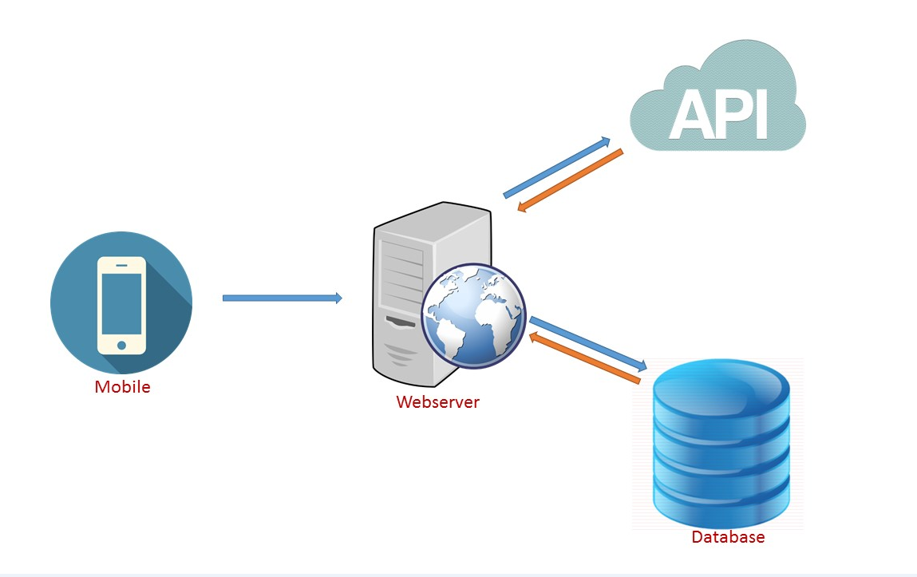

**Increment-1**

In increment-1 we have implemented login and signup pages.

**Detail Design of Services:**

For the first time user, the user has to register for our application. For this he has to enter signup page and enter all the details provided. After successful registration the user can login into our application. We have provided forgot password feature where user has to enter his username and security answer to change his password.

This app has two main features to use:

1. Journey reminder
2. Shopping reminder

**Class Diagrams:**

**Login Page**

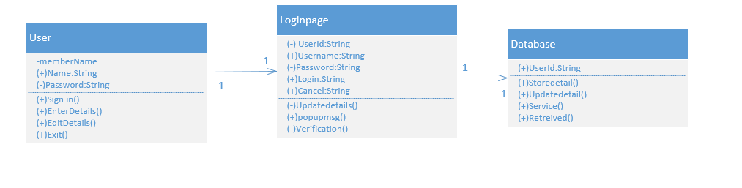

**Registration Page**



**Sequence Diagram:**

**Login Page**



**Registration Page**



**Design of mobile client interface:**

**App Icon on Mobile:**

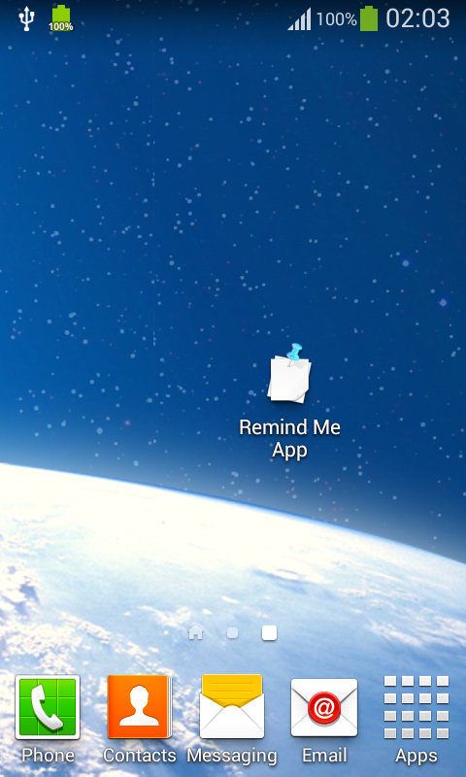 

**Login Interface:**

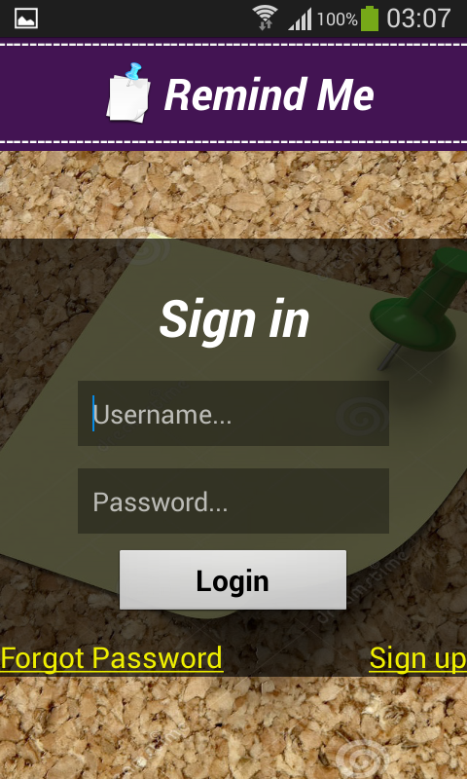 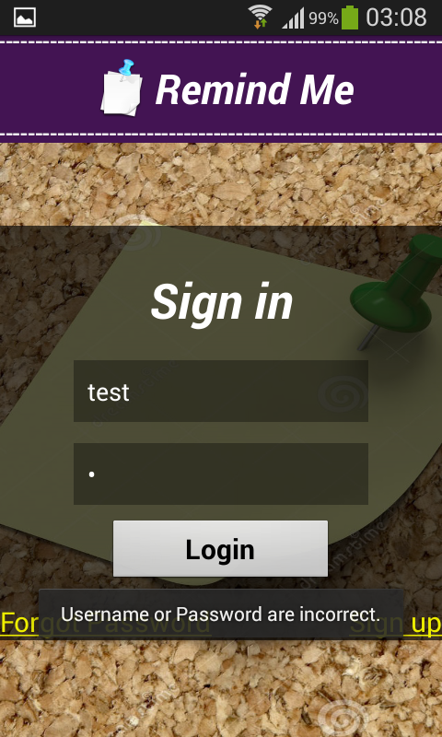 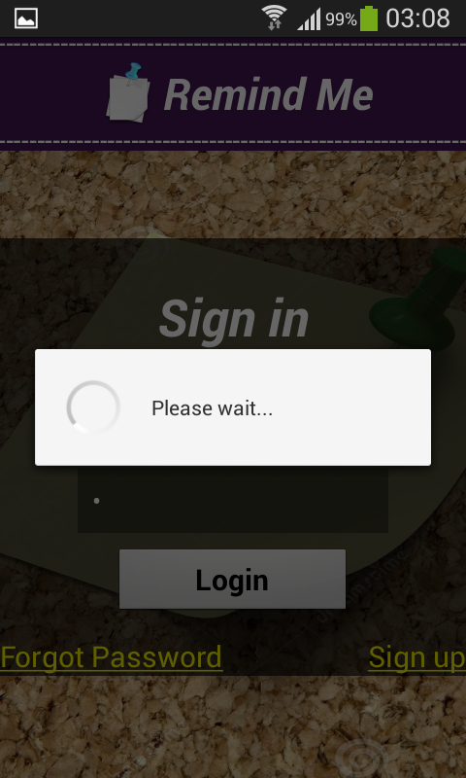

**Register Interface:**

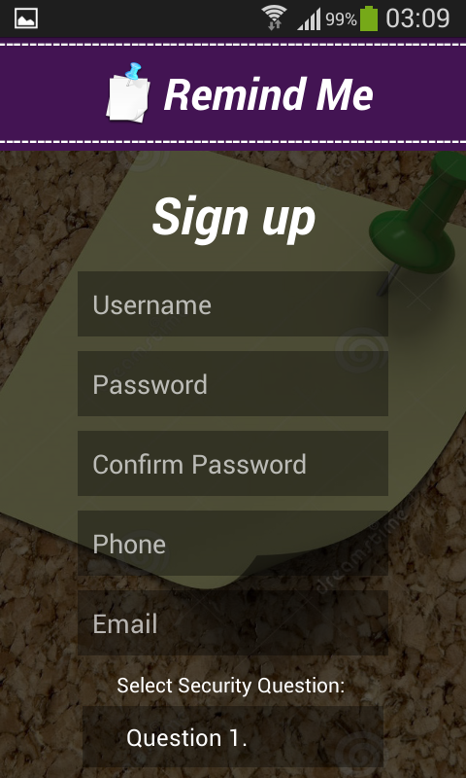 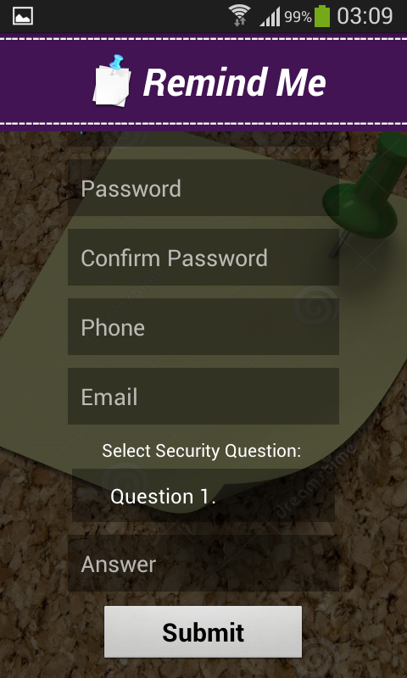

**Implementation:**

**Implementation of REST Services:**

We are implementing rest services using advanced rest client, with Mysql database.

We used Java with Jersey framework to work on this.

**Implementation of User Interface:**

**Login Page:** Once the user selects Login Button, he gets directed to Login Page.

If the user enters correct details, then Login successful message gets displayed.

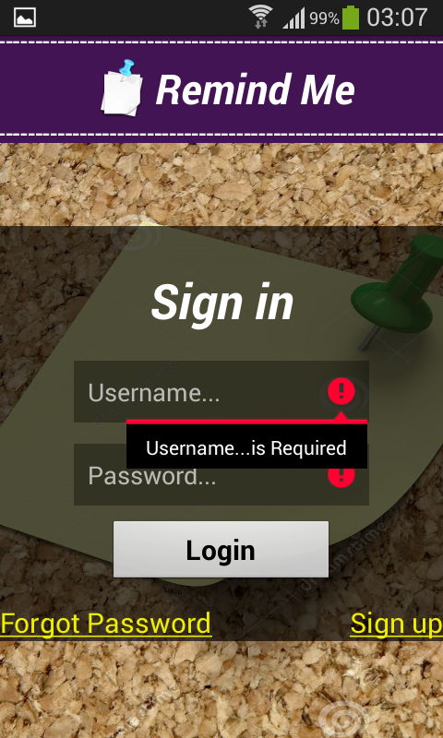 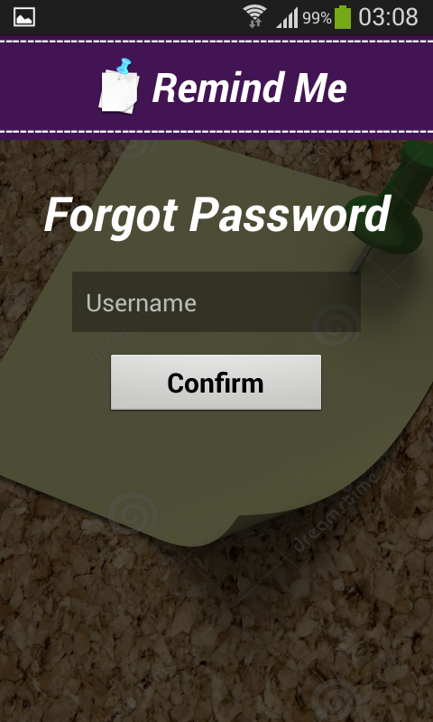

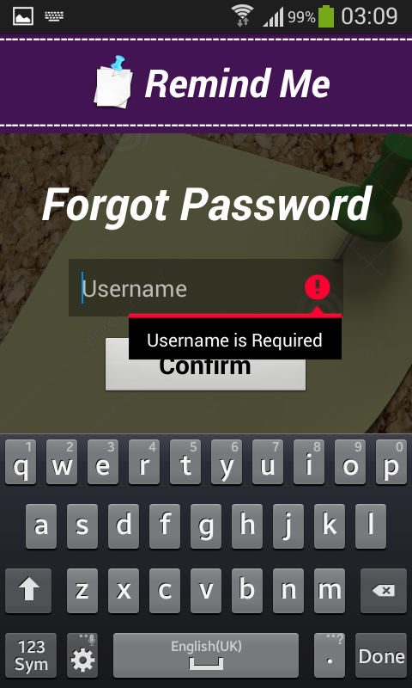 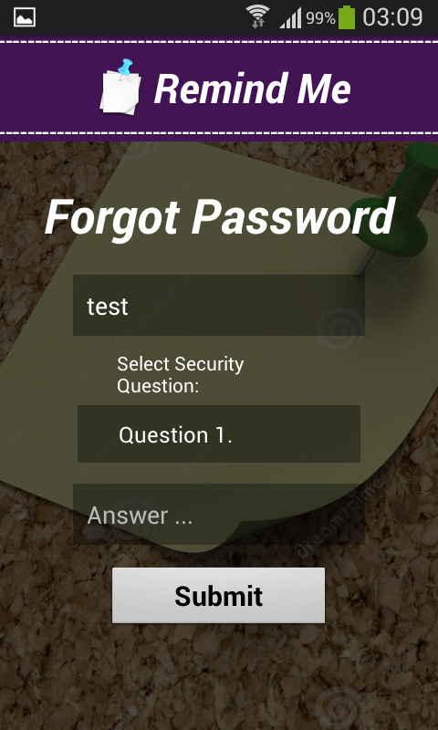 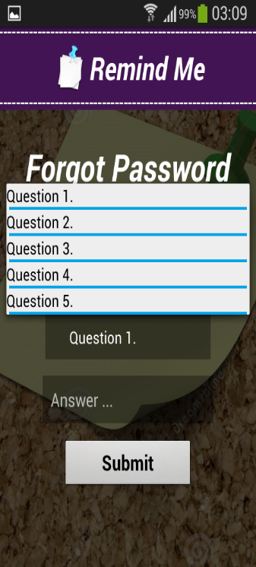

**Implementation of Register Page:**

**Registration Page:** Once the user selects the Registration tab, the user s directed to this page, where he enters his details for registration.

The registration is done successfully only if the user enters same password and confirm password, else he gets a message saying “Passwords doesn’t match”.

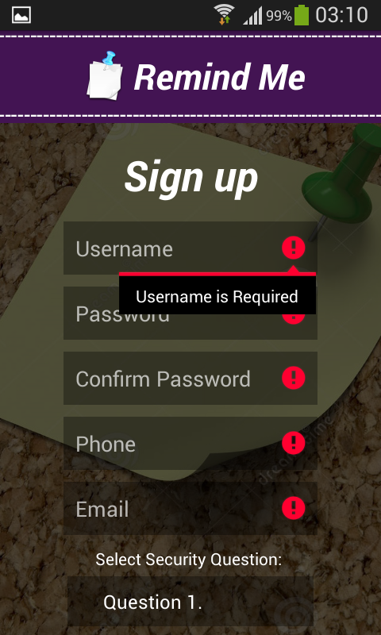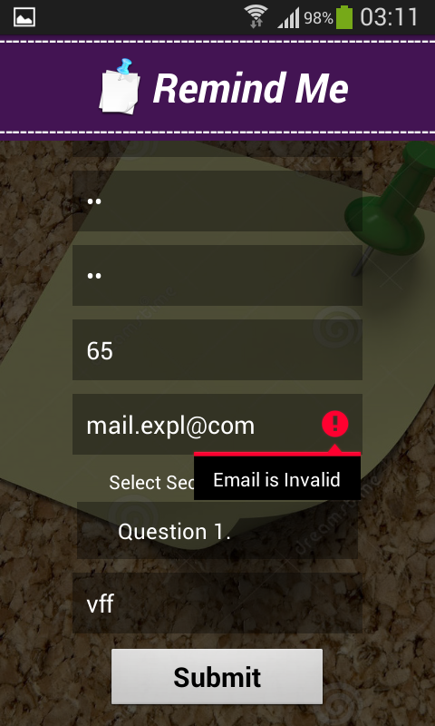

**Implementation of Unit Test Cases:**

**Login page:**

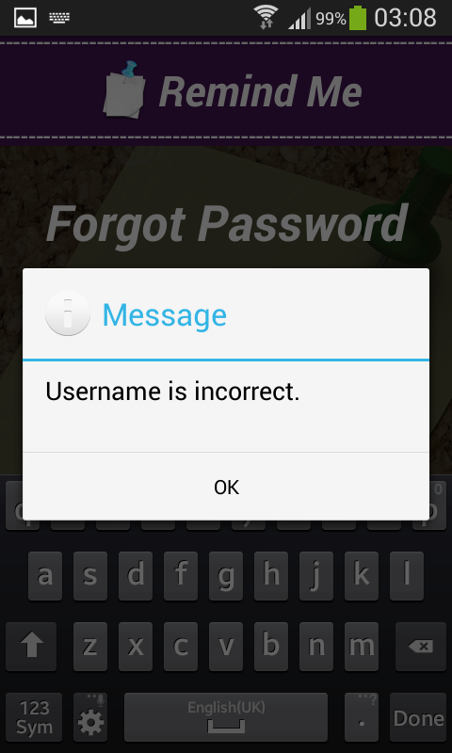

**Register Page:**

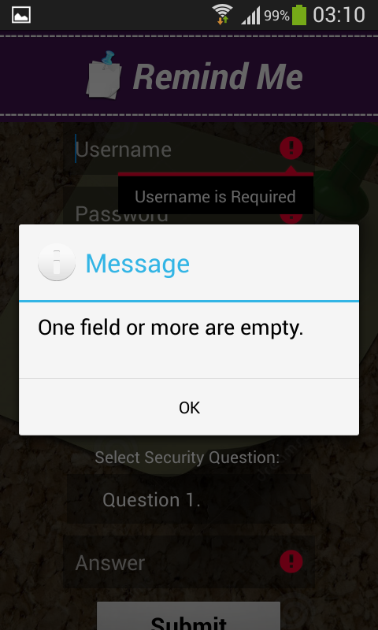 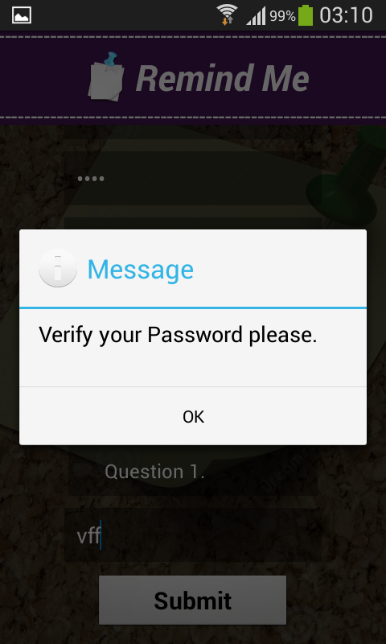

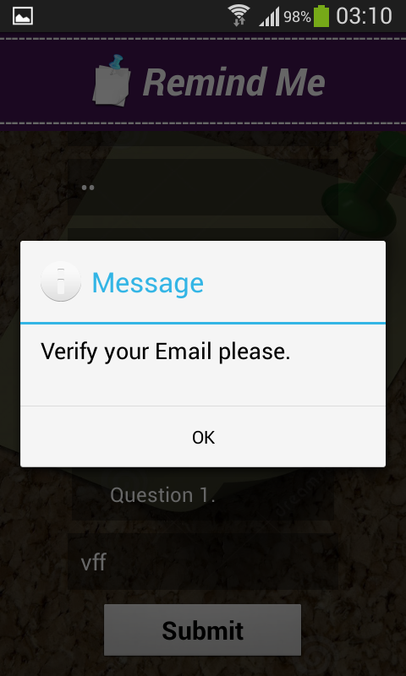

**Testing:**

For testing our Remind me application we used google advanced rest client services.

As this provides all the post, get and other functionalities we require as mentioned above in the document and gives the test result by taking the input instantly, we preferred google advanced rest client services.

**Case-1:**

**Checking Authorization :( Failed)**

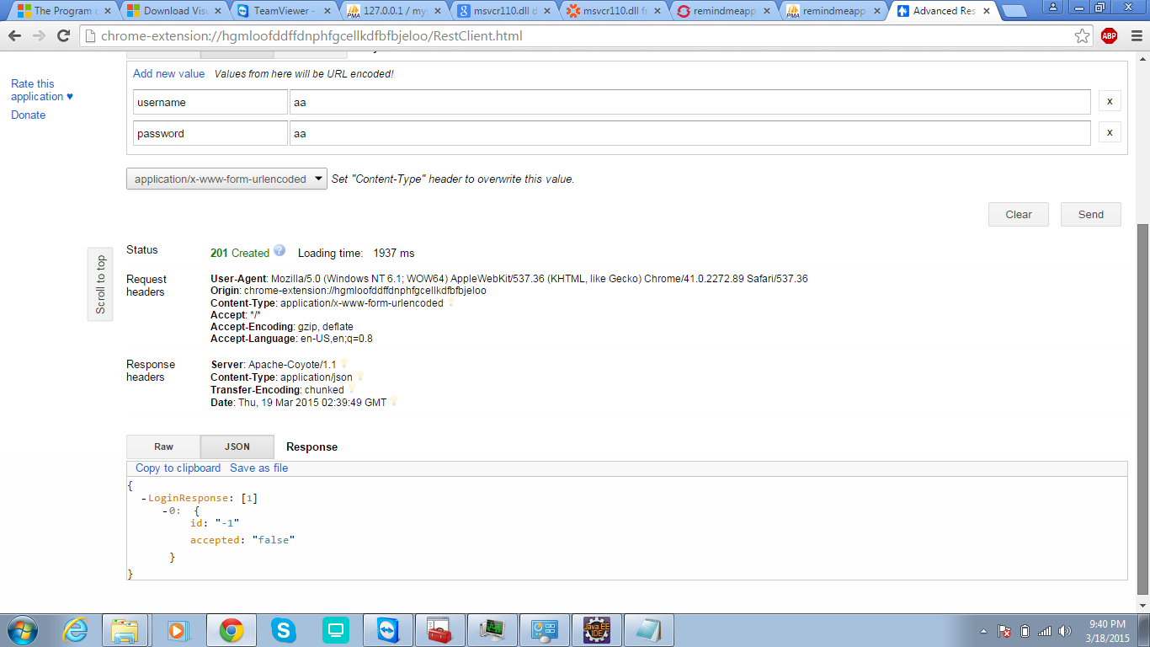

**Case-2:**

**Checking Authorization (Success):**

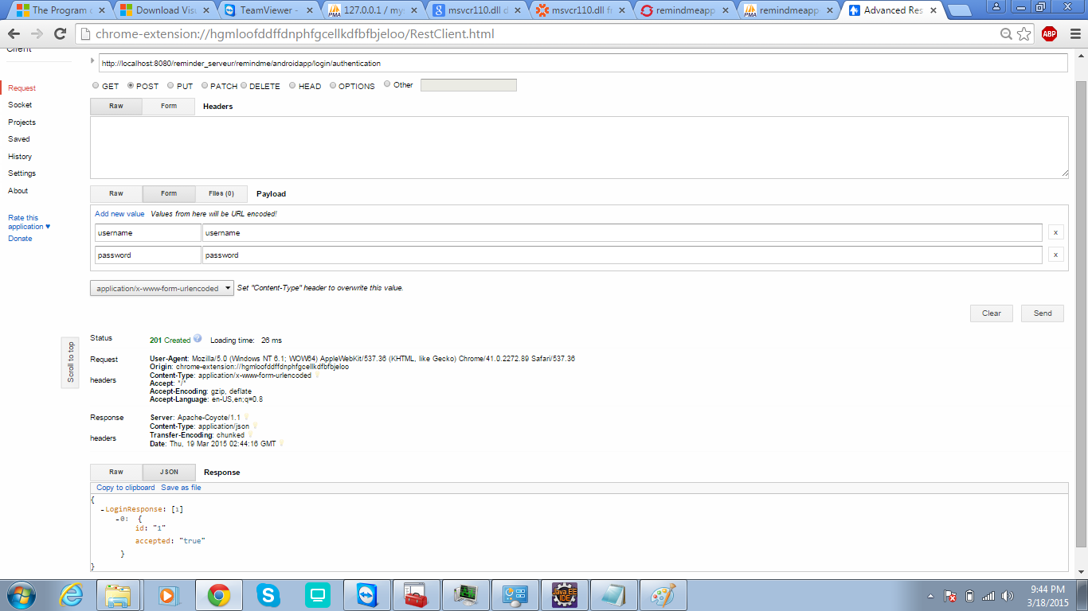

**Case-3:**

**SignUp-success:**

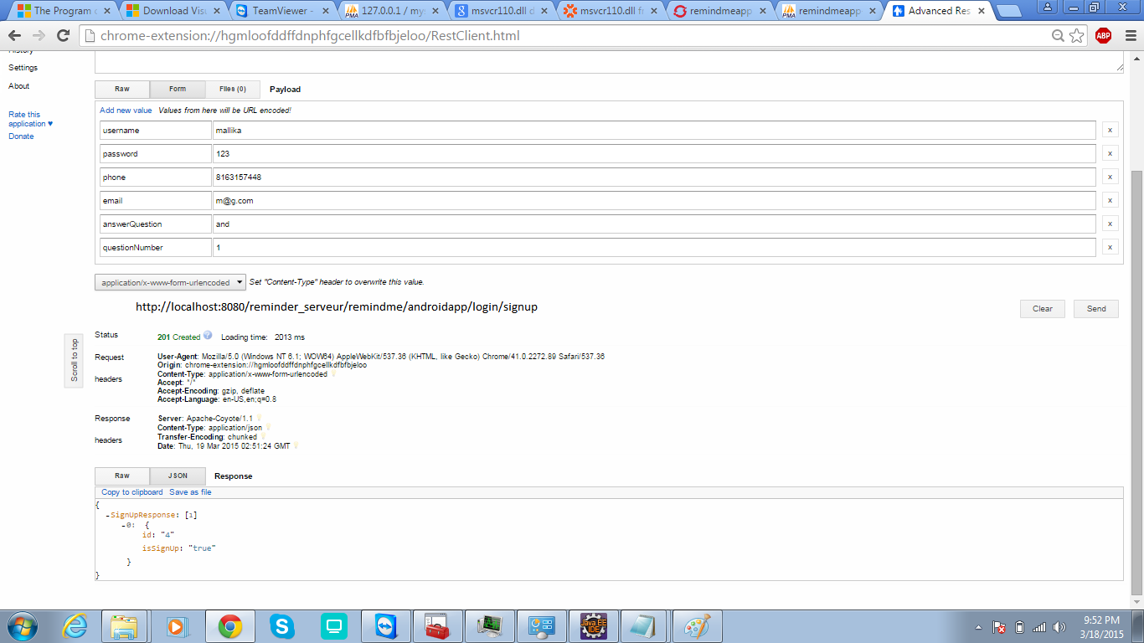

**Sign Up-failed:**

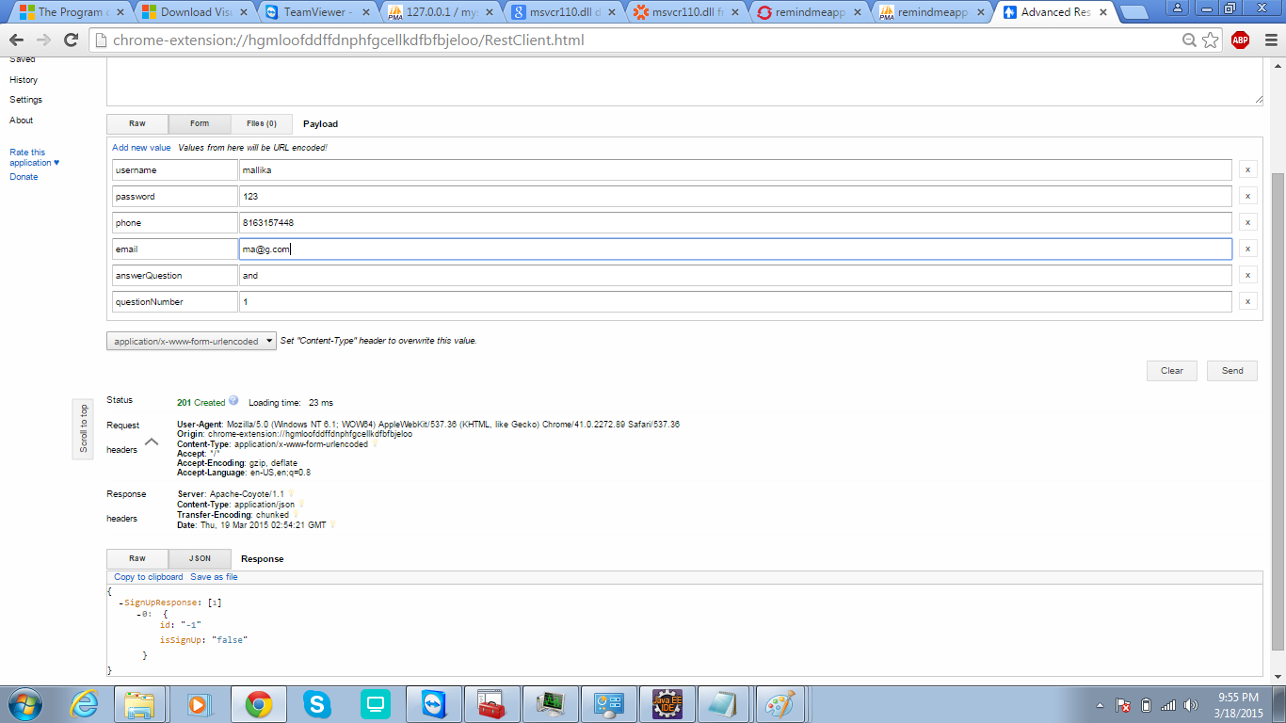

**Case-4:**

**Shopping cart creation-success:**

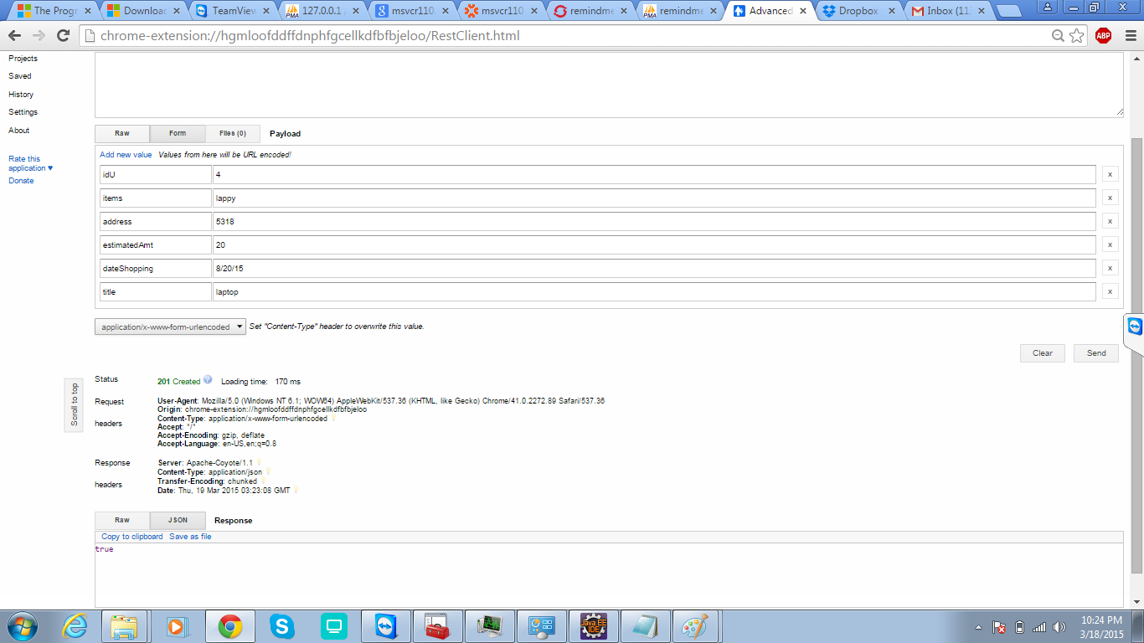

**Case-5:**

**Password-forgot(security query):(failed):**

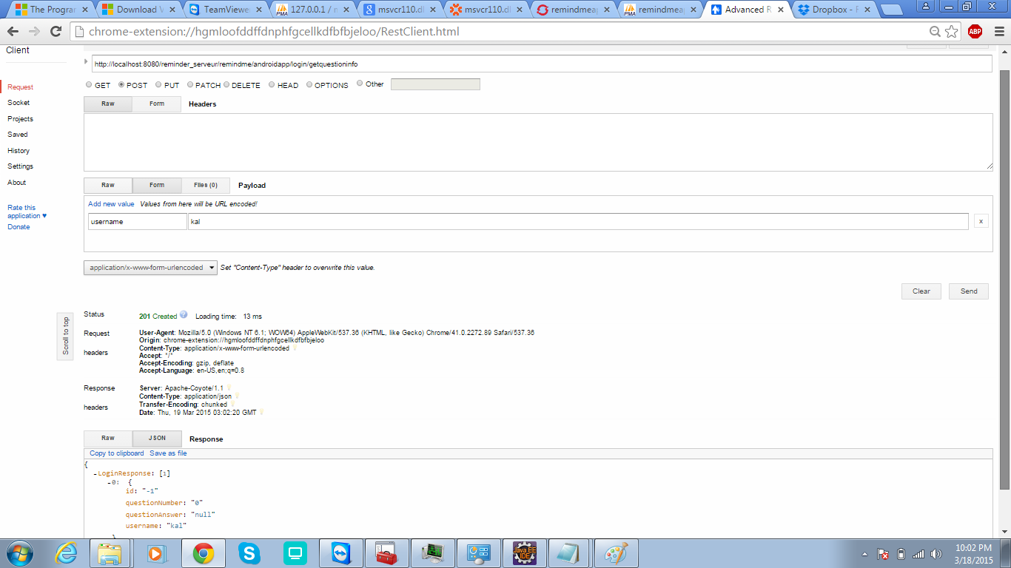

**Case-6:**

**Password-forgot(security query):(success):**

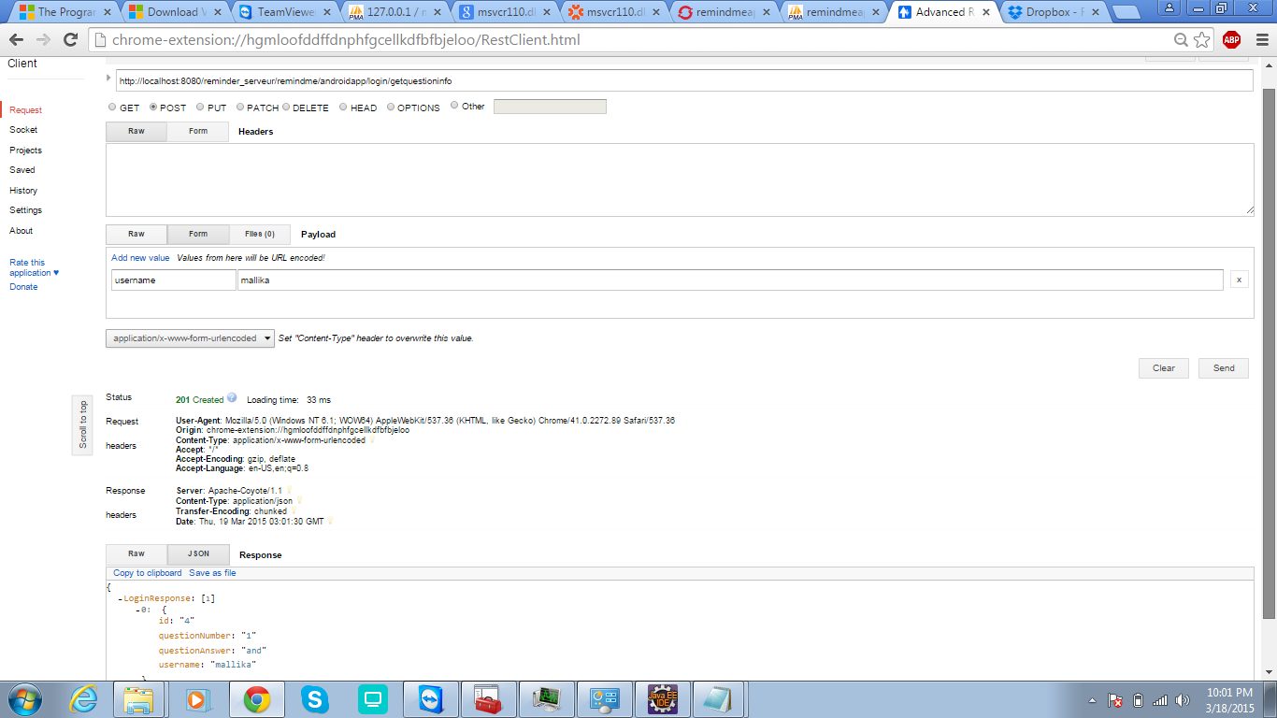

**Case-7:**

**New Password creation-failed:**

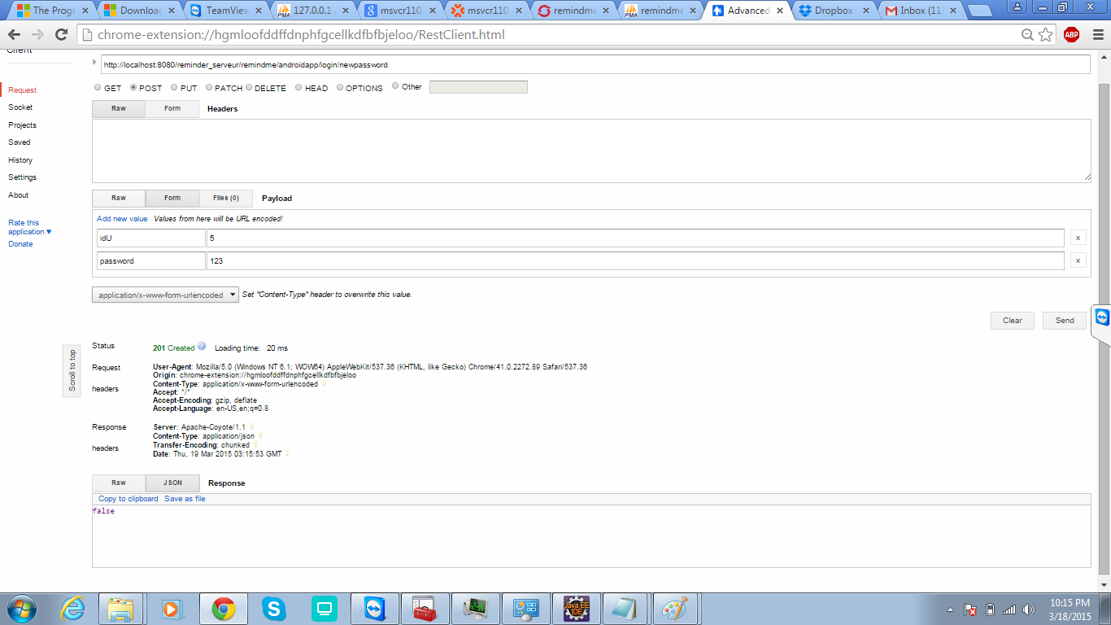

**New Password creation-success:**

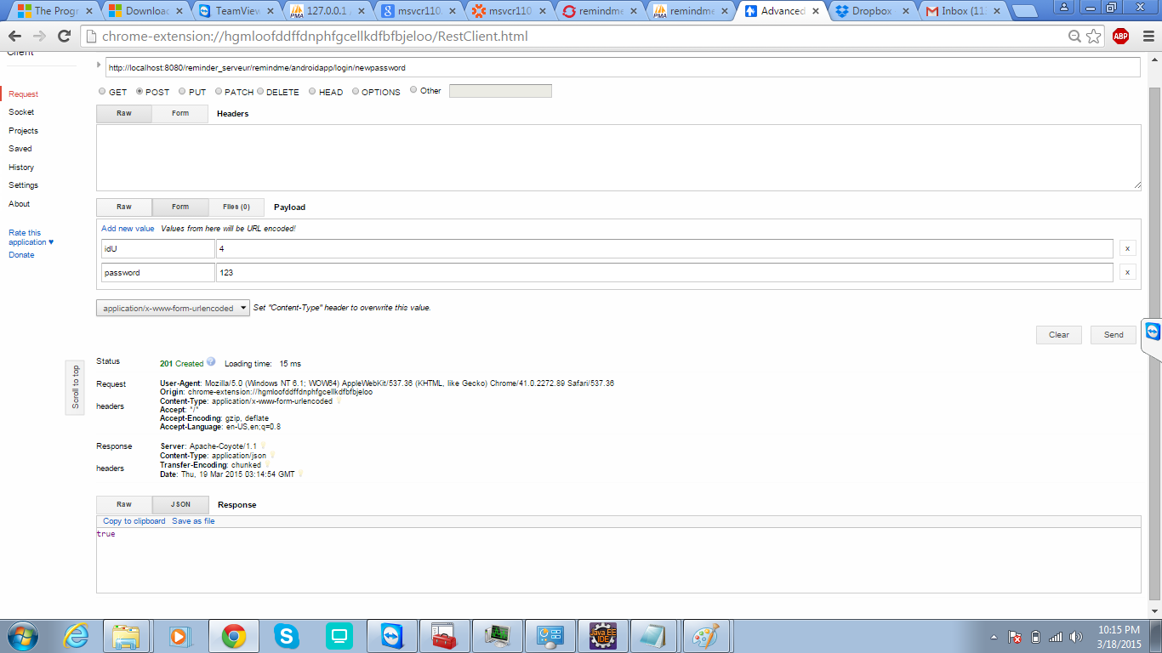

**Increment-2**

**Detail Design of Services:**

**Service Description:**

For 2nd increment we have implemented shopping tab.

**Shopping Tab:**

In this tab, the user has the facility to provide the list of items he needs to buy with the date and time.

So the user gets reminder at the specified date and time.

In this app we have additional features like:

1. At the time of appointment, if he is at some other location, then the app provides him with the directions to the nearest stores where he can buy the items.

Here the user has 3 choices of services that are provided by our Remind Me application.

The user can add a new list to reminder or user can search an item on the store or user can get directions to the store.

**Service 1:**

If the user wants to add a reminder he/she can go to add reminder service and can add a reminder by providing the time and details of the reminder.

The user can save his list and later he/she can update or delete the items.

**Service 2:**

Suppose if the user wants to search a product on the store, the details of the product should be provided in the search column.

As a result all the list of products related to that name will be displayed using shopping service we implemented.

**Service -3**

The user can check details about the items at different locations of the store.

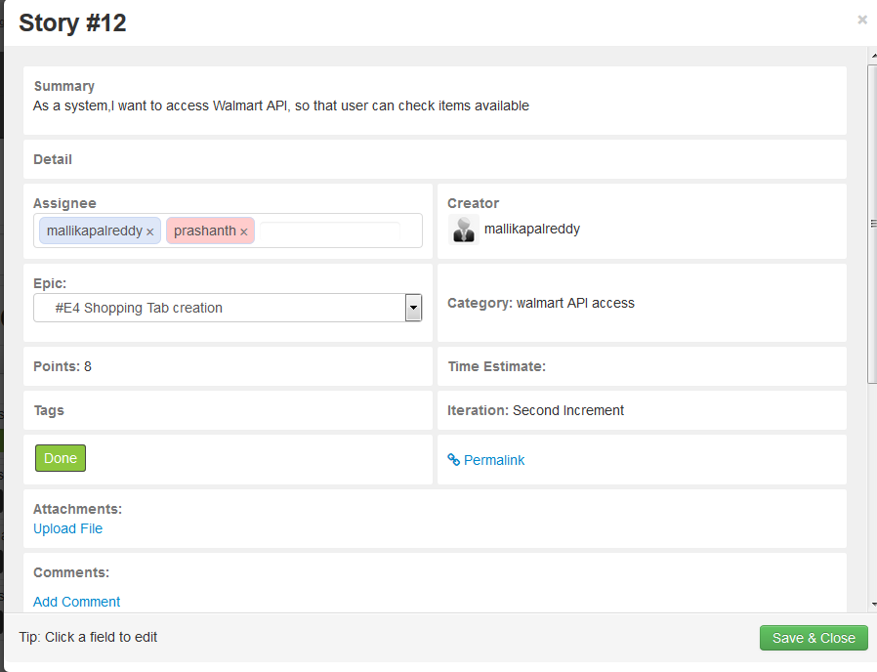

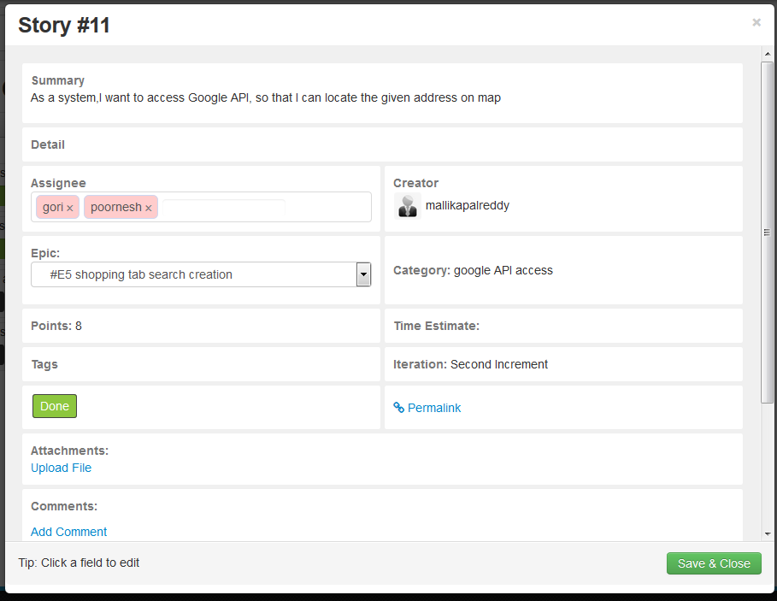

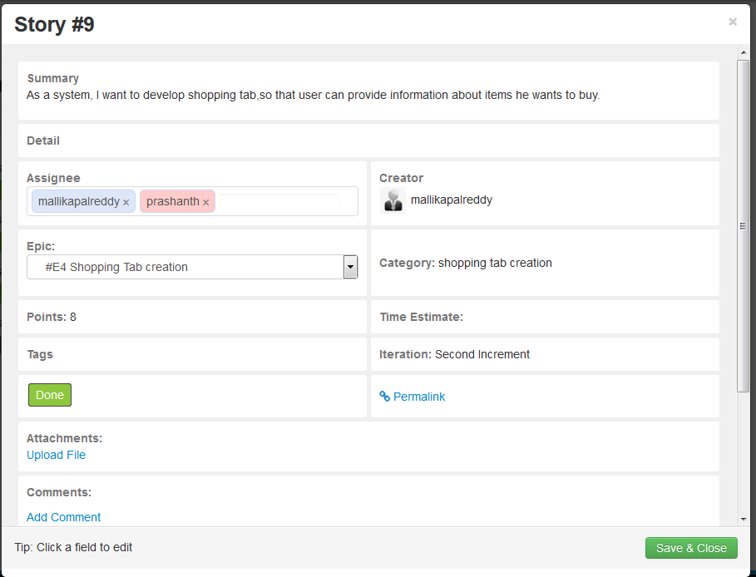

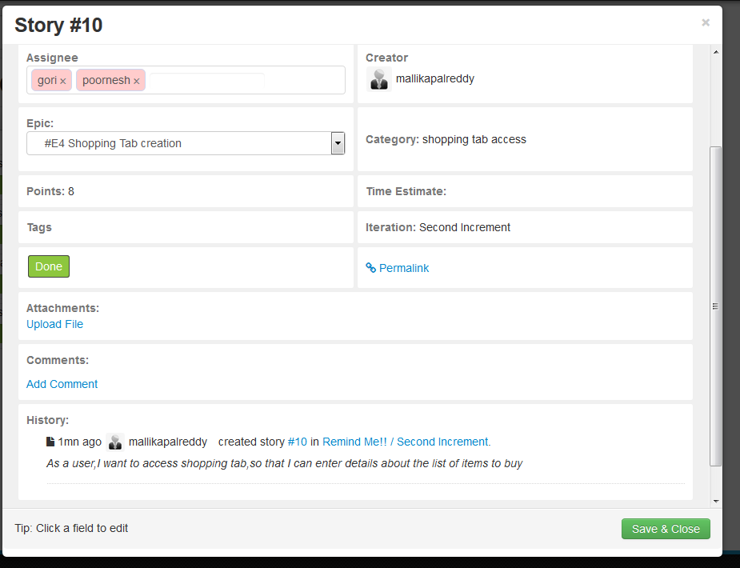

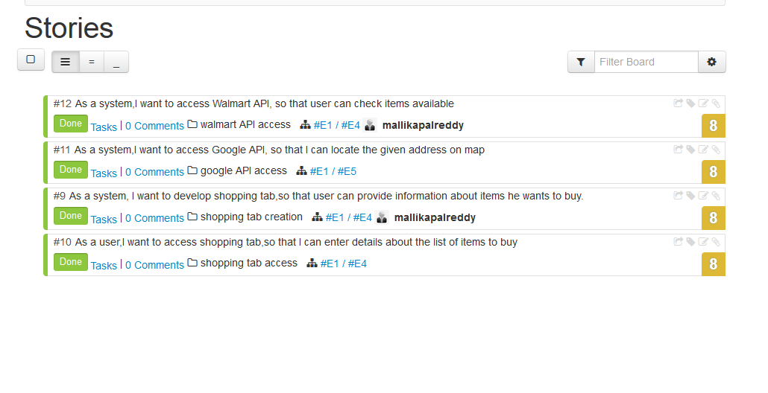

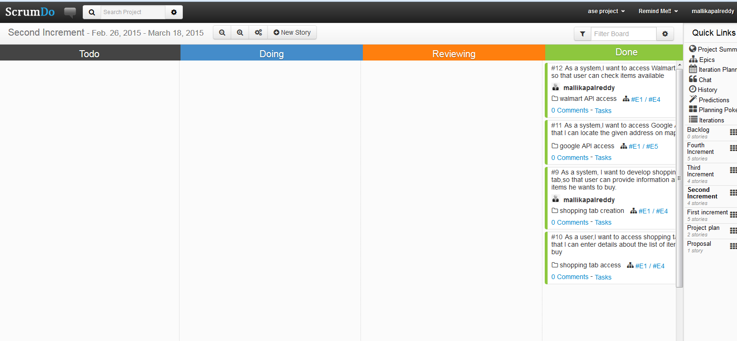

**Class Diagrams:**

**Shopping Tab**

**Class Diagram:**

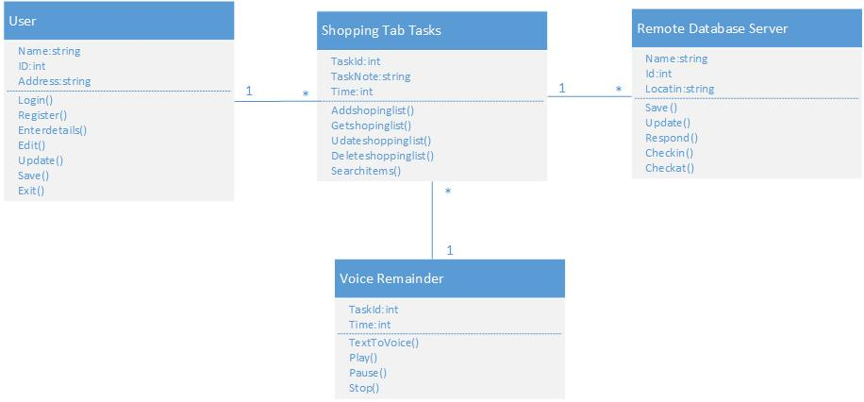

**Sequence Diagram:**

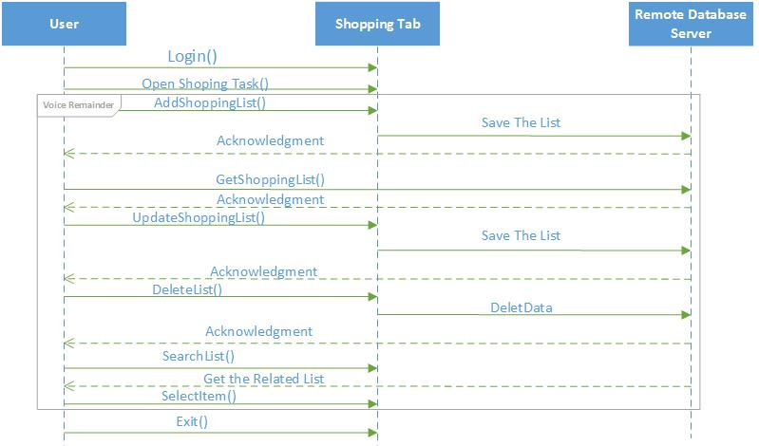

**Design of mobile client interface:**

**Shopping Tab Interface:**

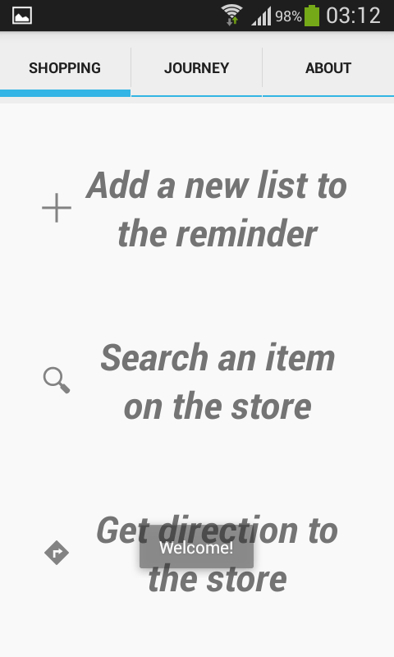 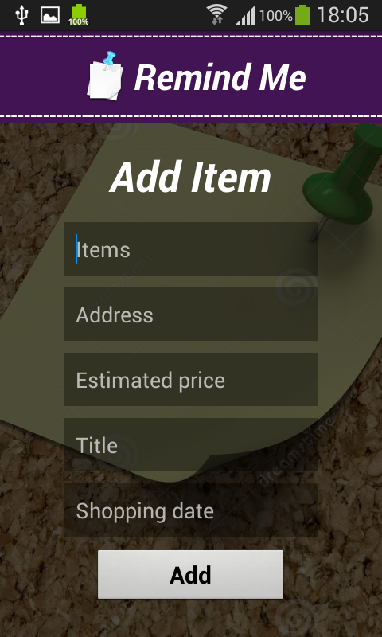 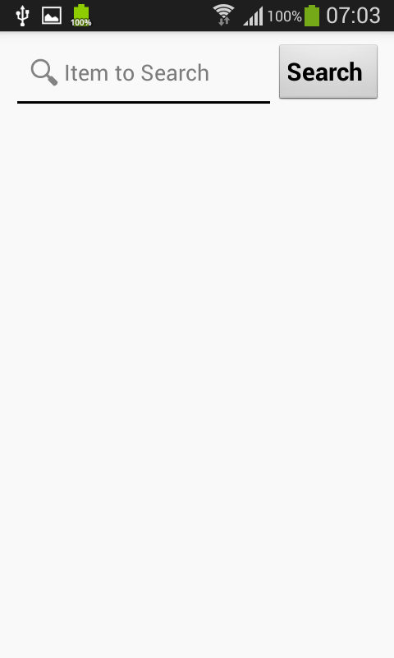

**Implementation:**

**Implementation of REST Services:**

We are implementing rest services using advanced rest client, with Mysql database.

We used Java with Jersey framework to work on this.

**Implementation of User Interface:**

**Shopping Tab:**

 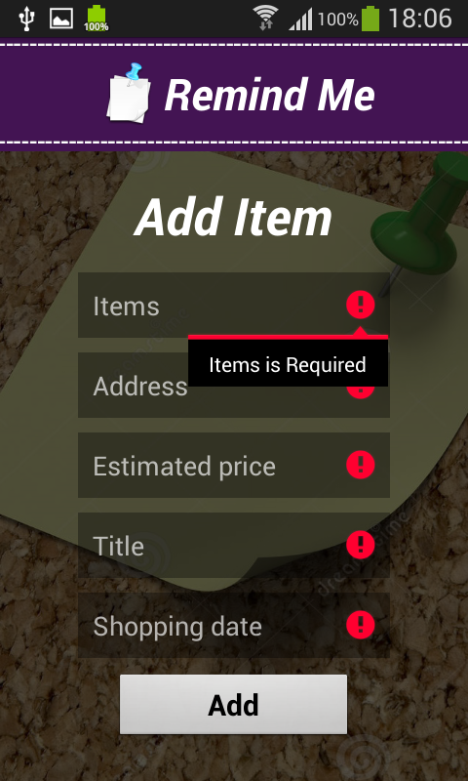

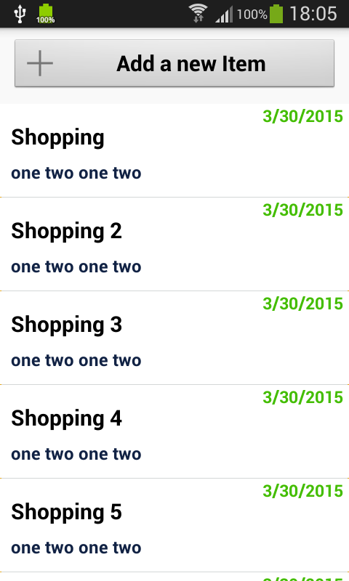 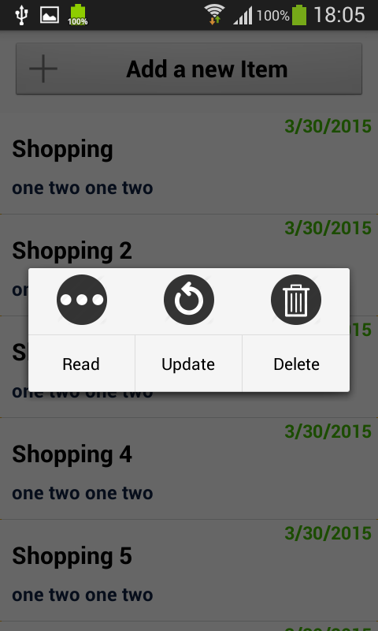

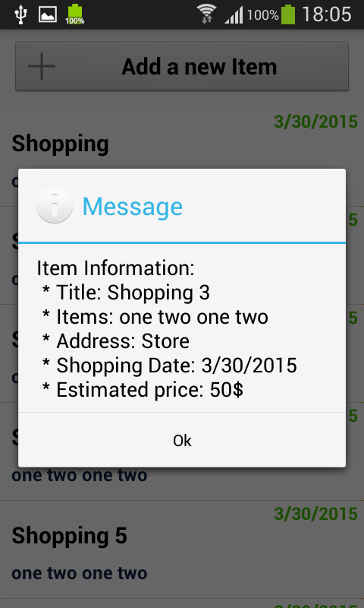 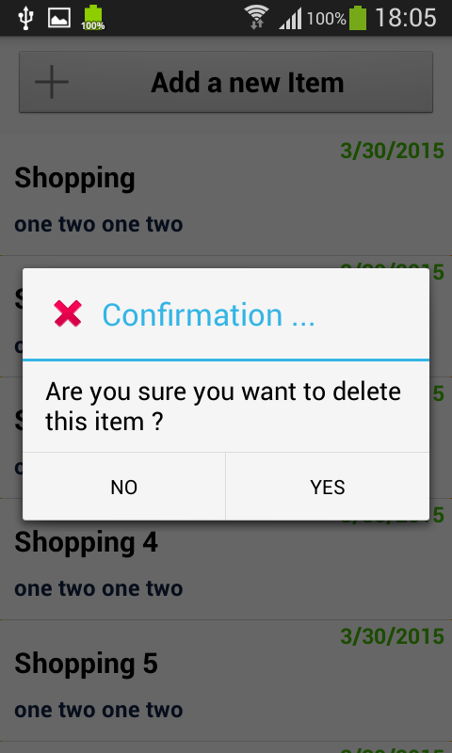

**Implementation of Search Service:**

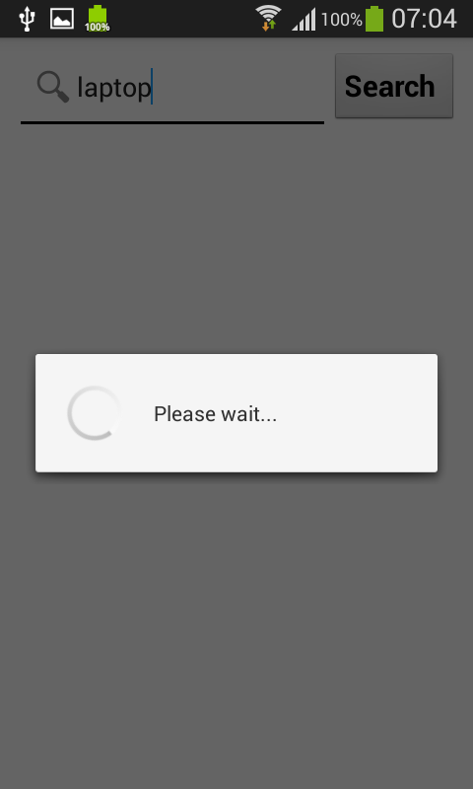

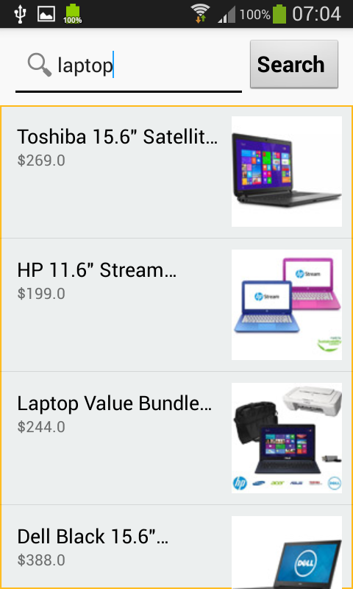 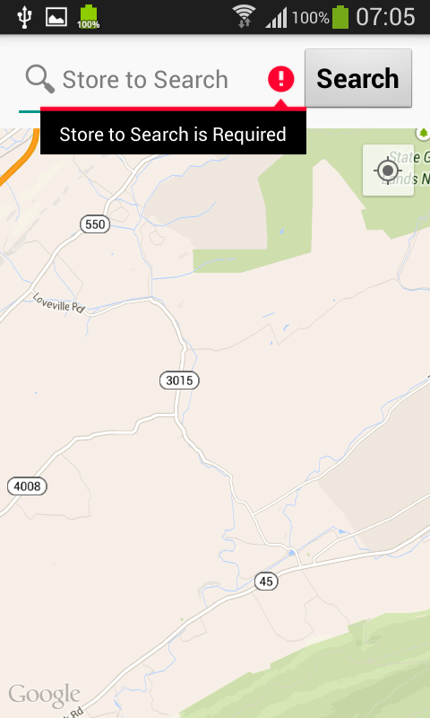

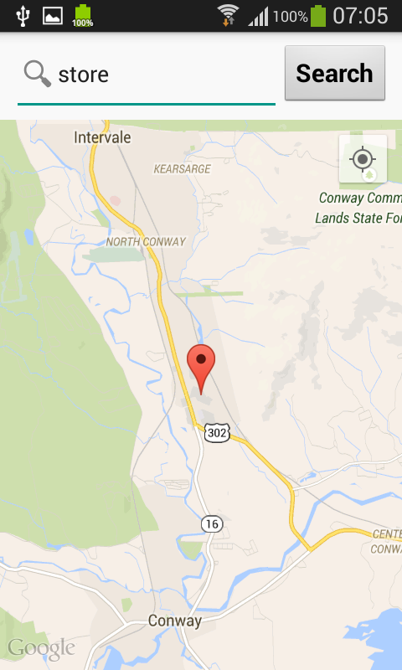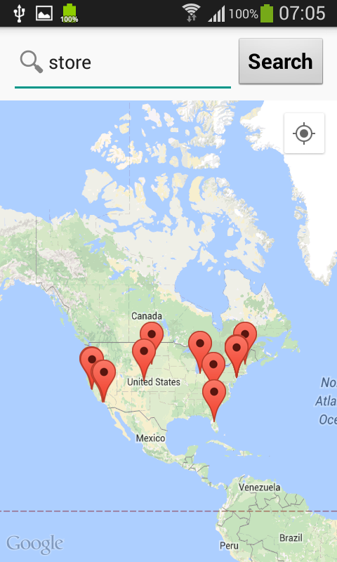

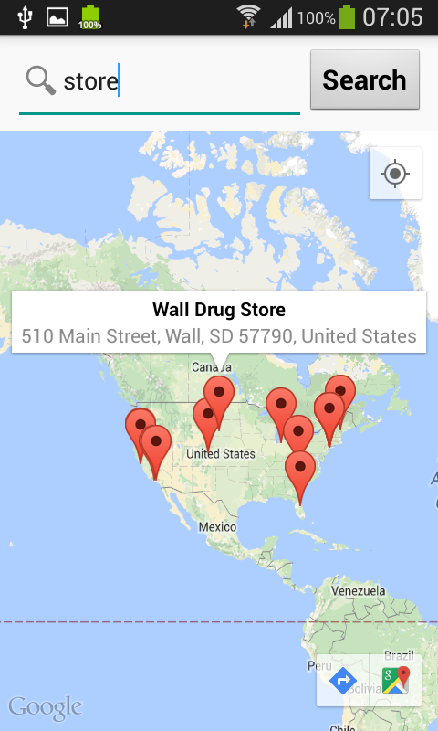

**Implementation of Unit Test Cases:**

**Shopping Tab:**

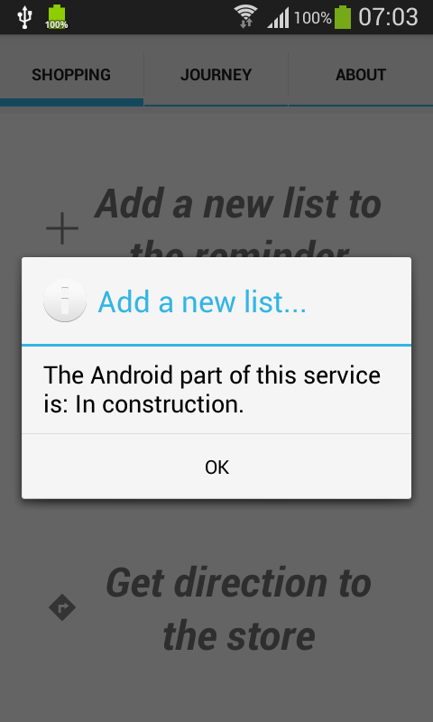

**Testing:**

For testing our Remind me application we used google advanced rest client services.

As this provides all the post, get and other functionalities we require as mentioned above in the document and gives the test result by taking the input instantly, we preferred google advanced rest client services.

**Case-1:**

**Shopping cart creation-success:**



**Increment-3**

**Detailed design of services:**

***Service description:***

In this application we are going to develop a reminder application which can be used for multiple purposes. One of the feature is Journey Tab

Once the user successfully logs in to our application, he has 3 tabs:

1. Shopping tab
2. Journey tab
3. About tab

Increment-3 goes with the Journey Tab.

**Journey tab:**

In the Journey tab, the user can add his journey details: *source* and *destination* with respective times and dates. Once the journey is added, he can update it or get its details or delete the journey.

To *add halts* to the journey, click on update and then click add halts button, he will be directed to a new page to provide details about the halts which gets reflected in our journey. He can add any number of halts he wants.

Once he created a journey, he should click on *start* button to start the application or *exit button* to stop the application.

**Scrum do screenshots:**

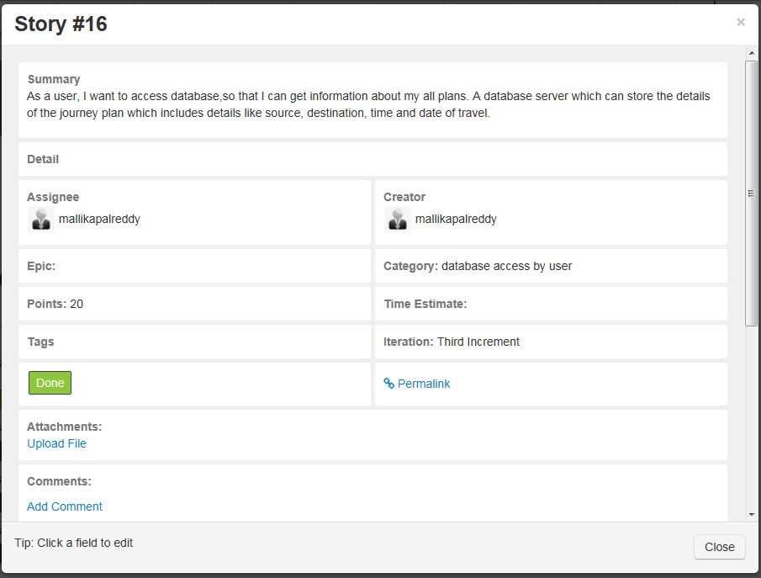

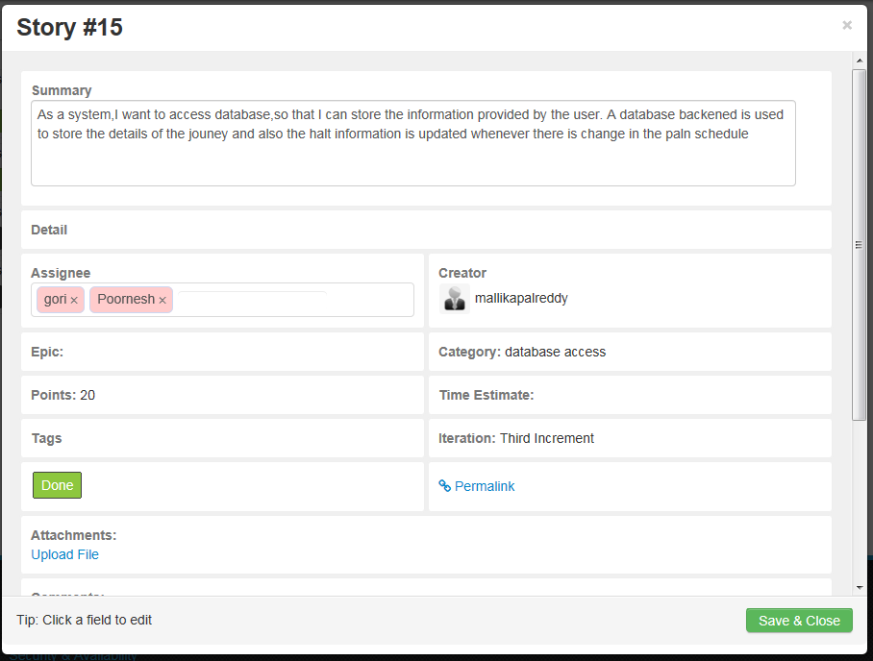

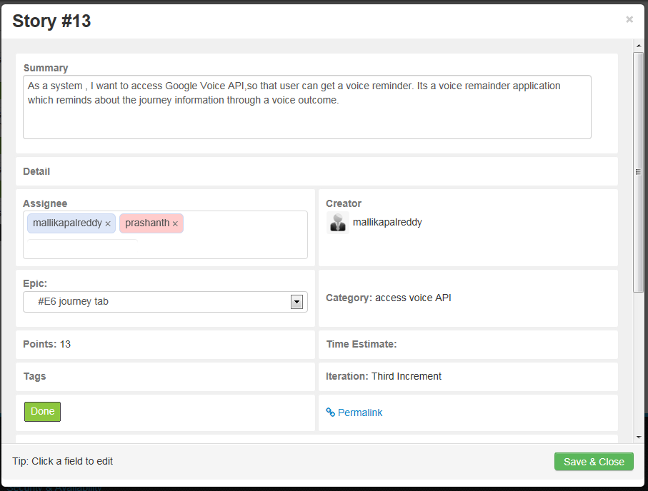

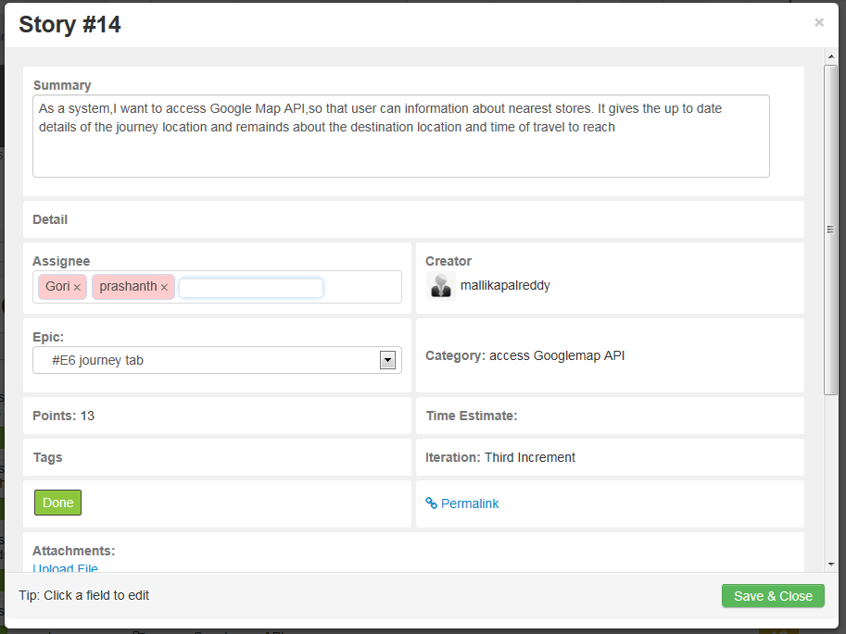

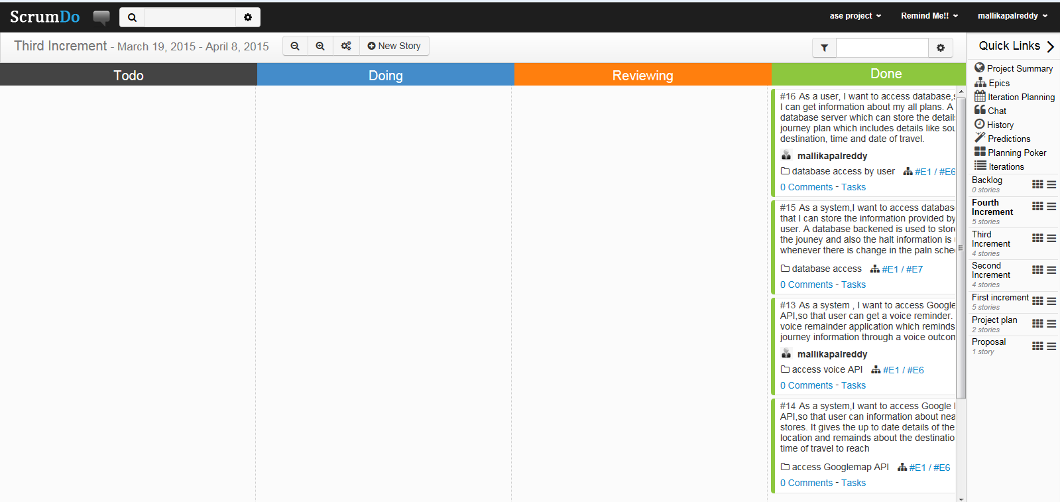

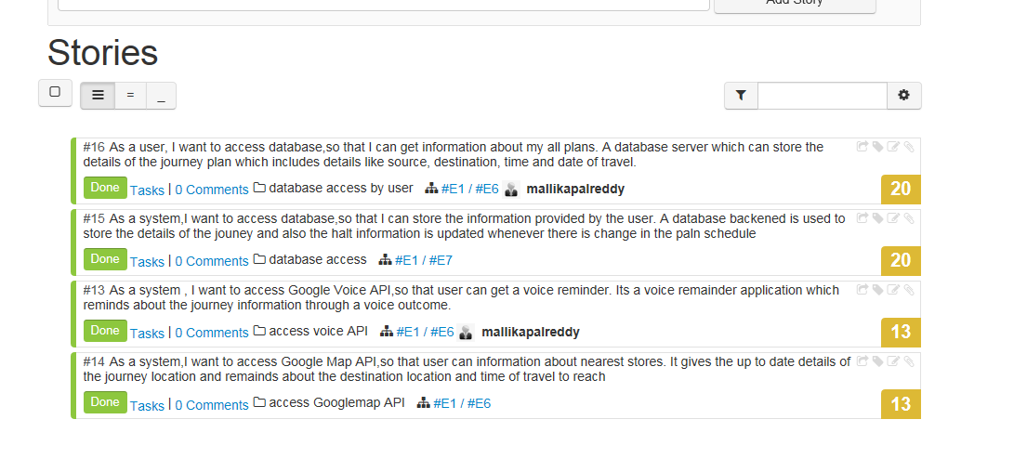

**Class Diagrams:**

**Class Diagrams:**

**Journey tab**

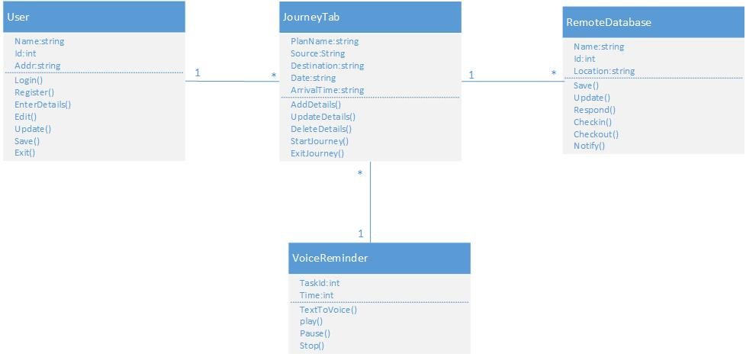

**Sequence Diagram:**

**Journey Tab:**

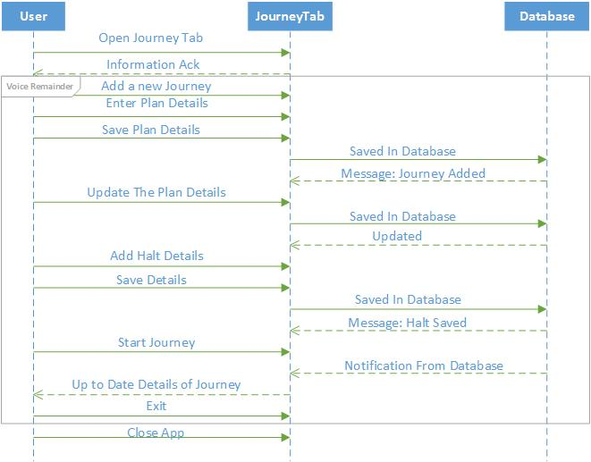

**Design of mobile client interface:**

**Implementation of REST Services:**

We are implementing rest services using advanced rest client, with MySQL database. We used Java with Jersey framework to work on this.

**Implementation of Shopping Tab:**

**Journey interface:**

1. Adding a journey

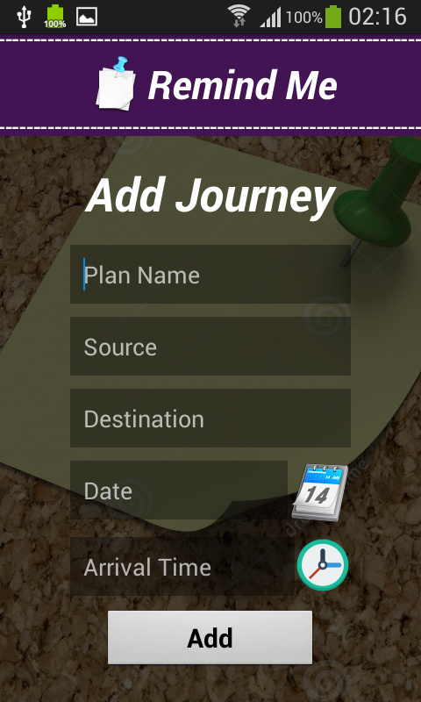 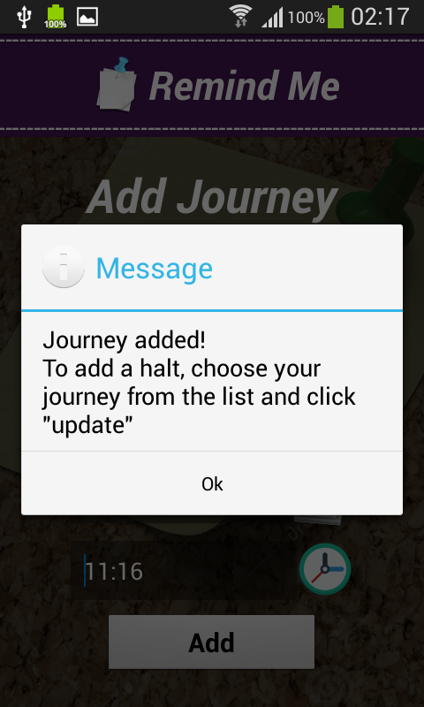

Displaying lists of journeys added.

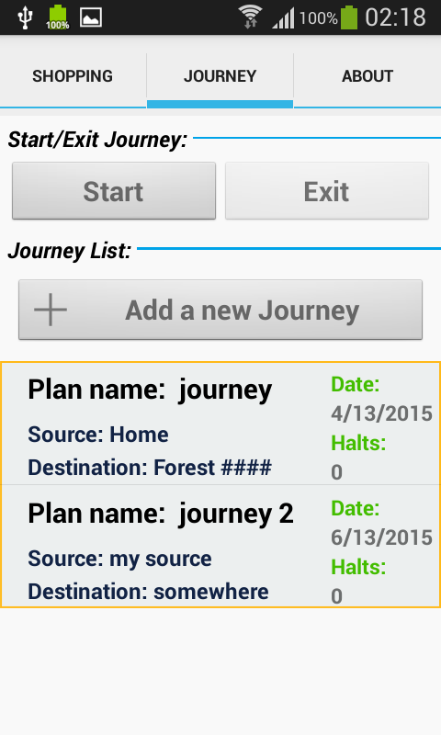

On click of journey added, here we have 3 options to select

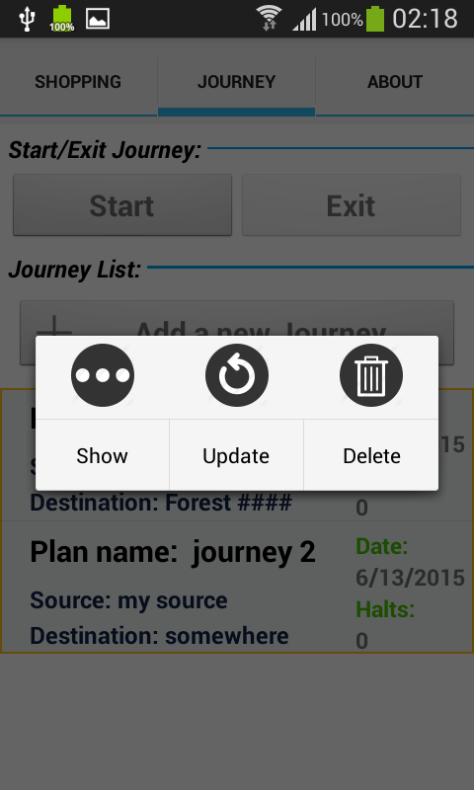

To update the journey, click on update. The below page will be displayed.

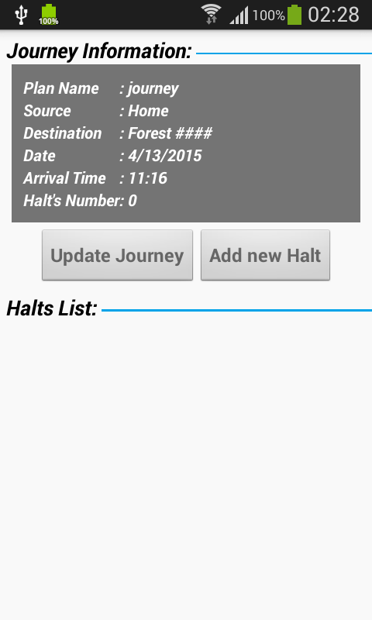

Here, we have 2 options:

1. To update the journey
2. To add halts to the journey

If we select update journey the below page appears,

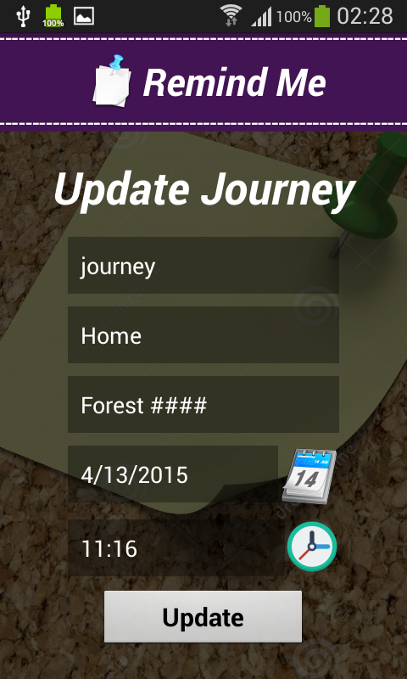

This page displays, when we want to set the time.

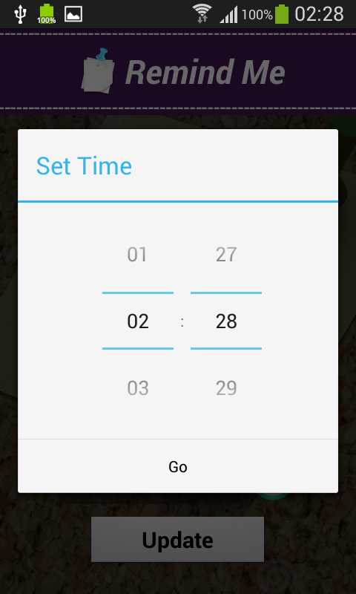

This page appears after successfully updating journey.

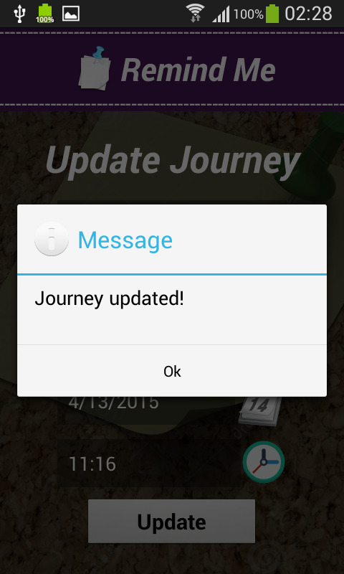

If we select option2: add halts, the below page appears

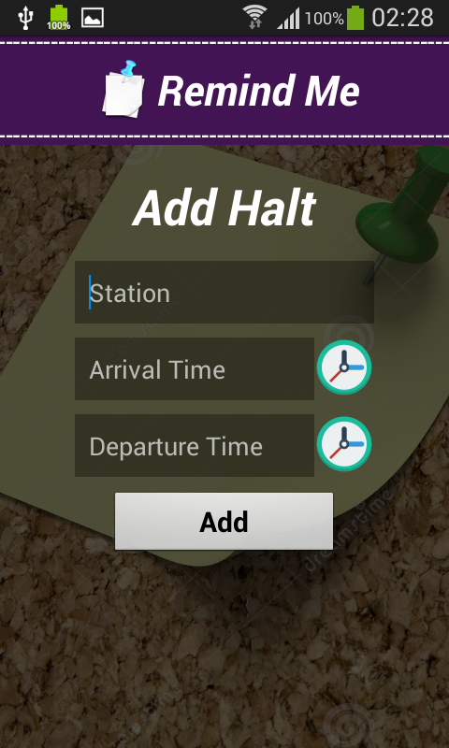

Message after successfully adding halt

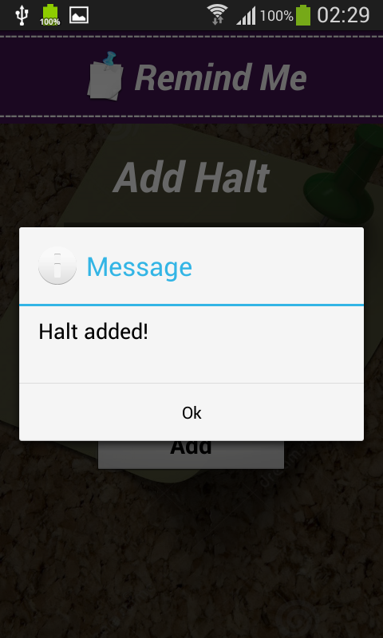

Once we are done with adding the journey, we have to click start button to start the application

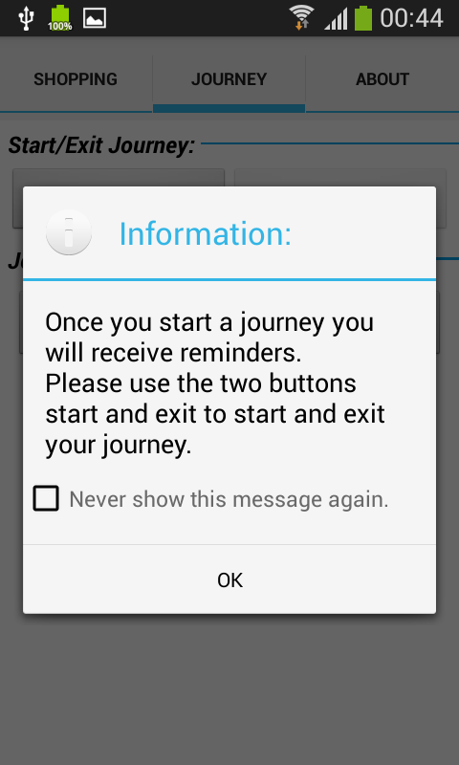

**Implementation of mobile client interface:**

**Journey tab:**

**Step 1:**  When we select journey option from the journey tab the following window opens.



**Step 2:**

Selecting “Add a new Journey” option from the above dialogue box the following information dialogue box appears.

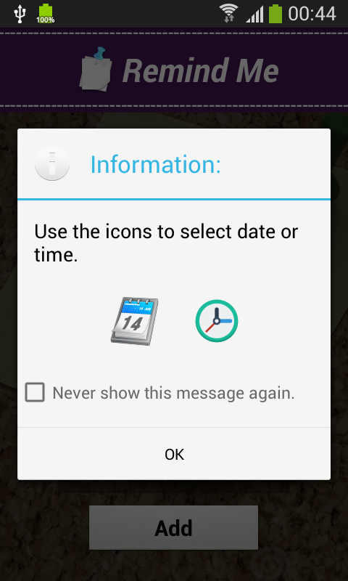

**Step 3:**

The details of the journey should be given in the corresponding tabs present above and if the details provided are inappropriate the following windows appear.

If the details are corrected by providing the required details the next window is appeared.

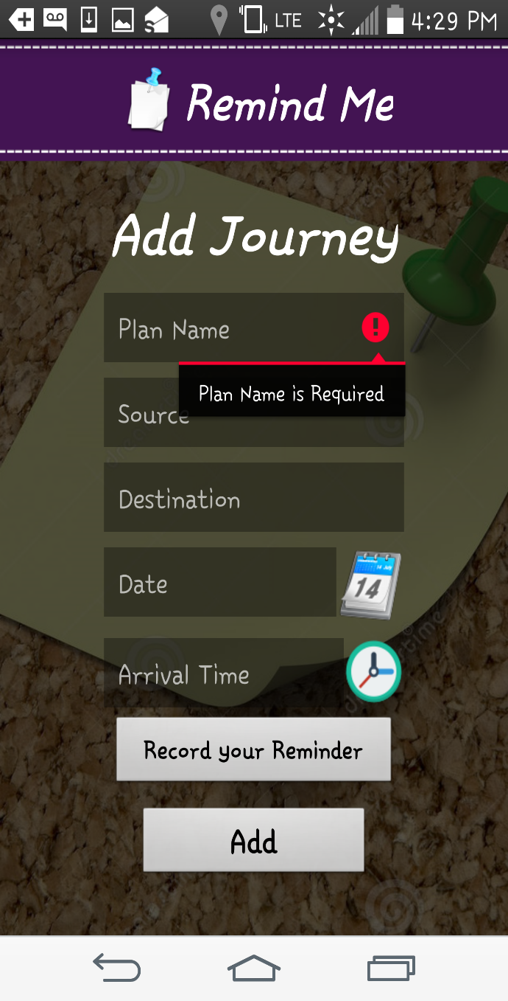

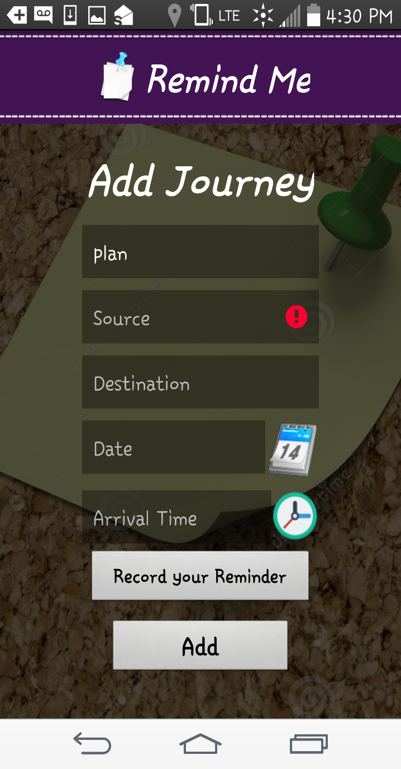

Here in the above adjacent window since source address is not provided an alert message is displayed for alerting the user to provide source address.

**Step 4:**

If the source address is provided and if destination address is not provided, in the next step an alert message for the user is displayed seeking for the destination address.

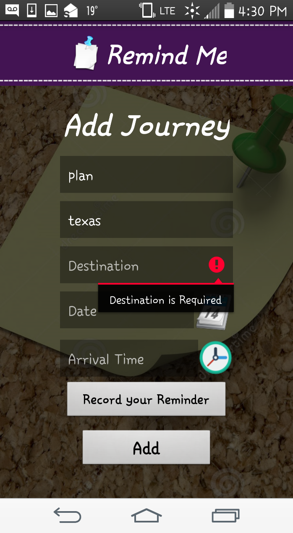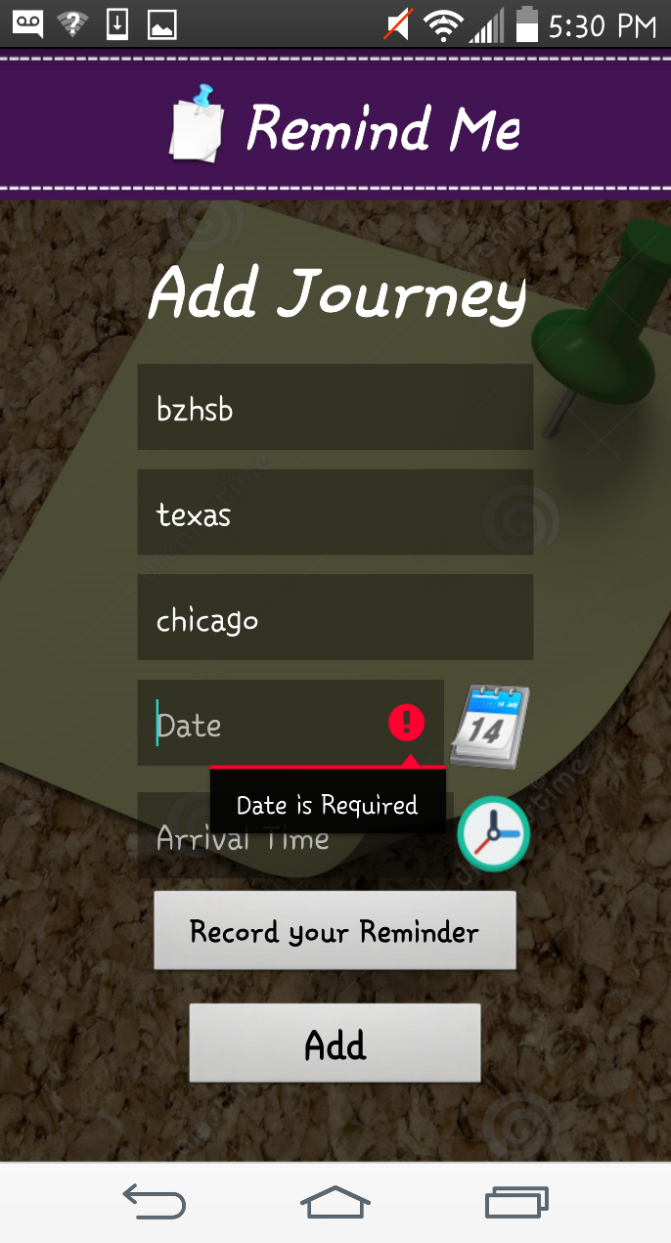

Similar an alert message is displayed for the date, time of arrival if the details are not provided by the user prior to the adding of the reminder.

**Step 5:**

The user can select the date from the date window that pops up when the calendar is selected.

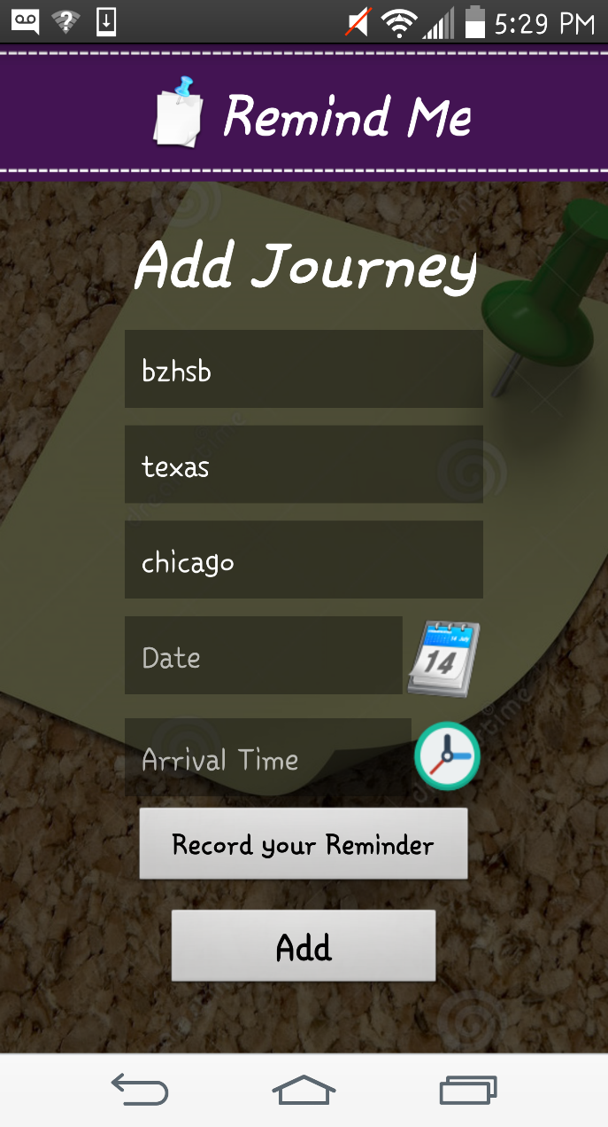

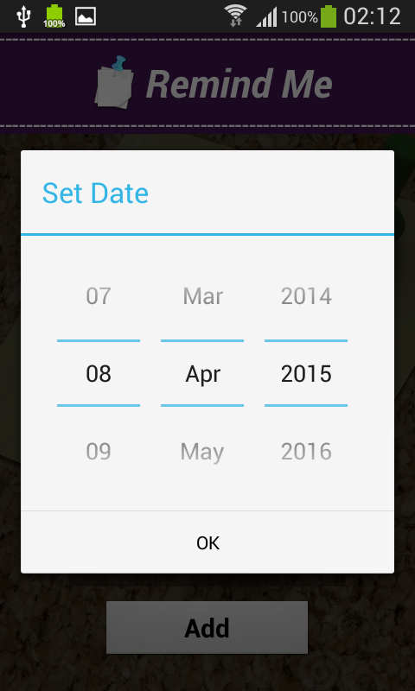

**Step 6:**

The user can select the time from the following popup message and once all the details are provided the journey will be added to the list of remainders and the window appears as shown here.



**Step 7:**

To add a new halt in the journey user can select add new halt tab and give the details of the halting place and time and update his record of journey from the following window.

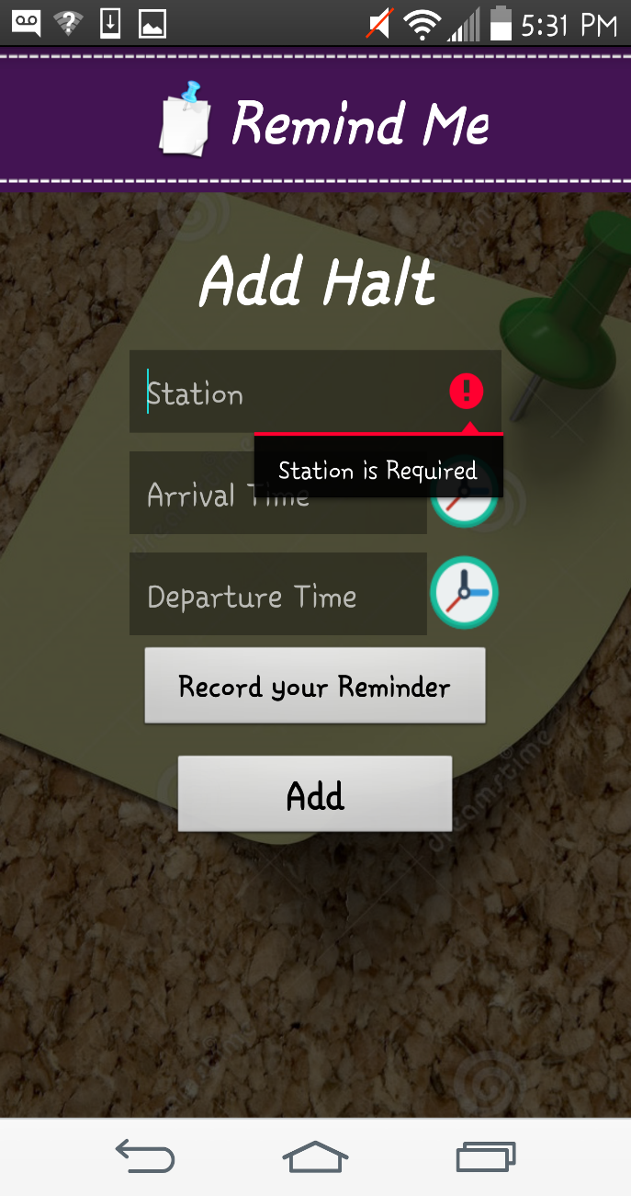

Similar to the alert messages that are provided in the above tabs here also if the required details are not provided an alert message is displayed to the user seeking information about that details.

**Step 8:**

Though all the details are provided by the user and if user did not provided/recorded the voice reminder a pop up alert is displayed as below. If the user wants to add a voice alert by recording his/her own voice reminder, user can do as follows that is shown in the adjacent window.

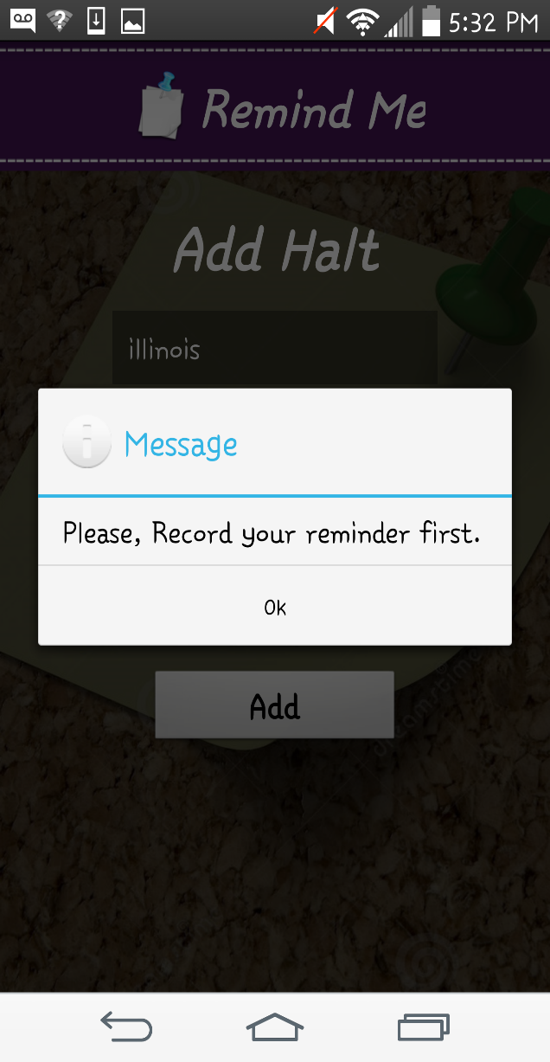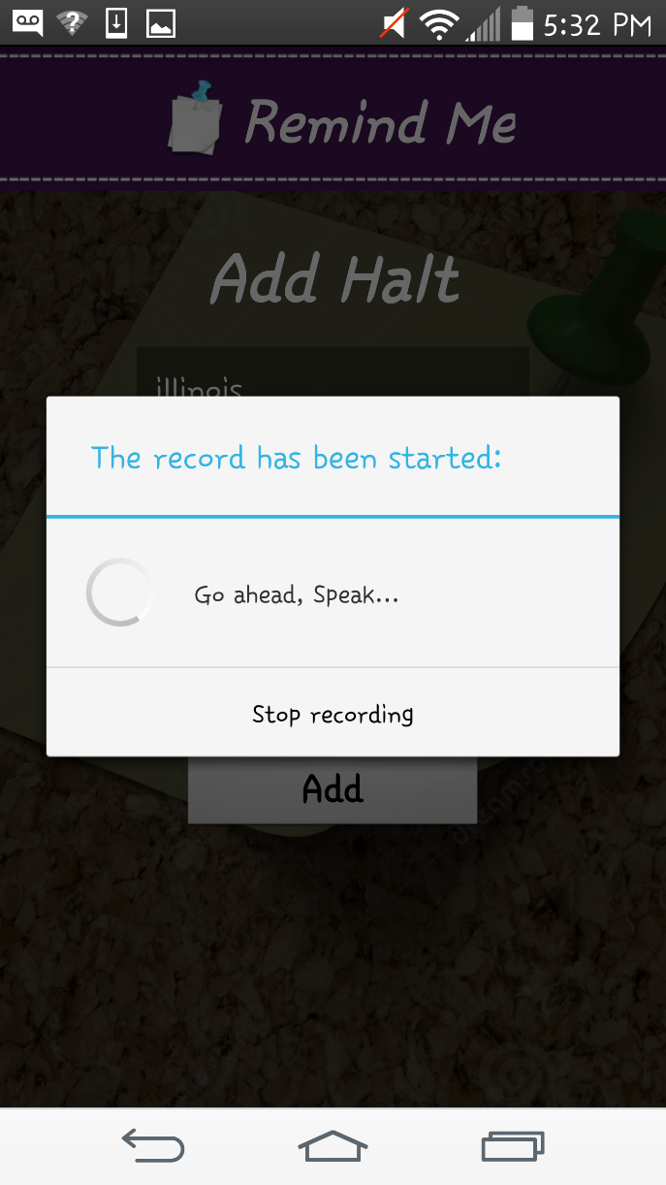

**Step 9:**

After all the details are provided by the user for the halt and also a voice reminder the halt will be successfully added.



**Step 10:**

If the user want to update the Journey details, it can be done as follows by selecting the options show/update/delete. If the user selects the Update option the adjacent window opens.

**Step 11:**

Once the journey is updated the following window appears. Similarly the halt can also be updated by selecting the update option which is shown in the above window. When the halt is also updated the following window appears confirming that the halt is updated.

 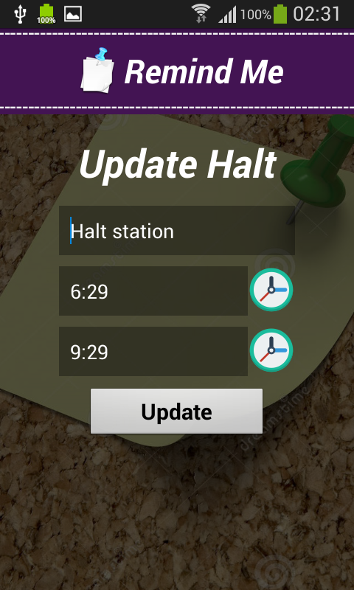

.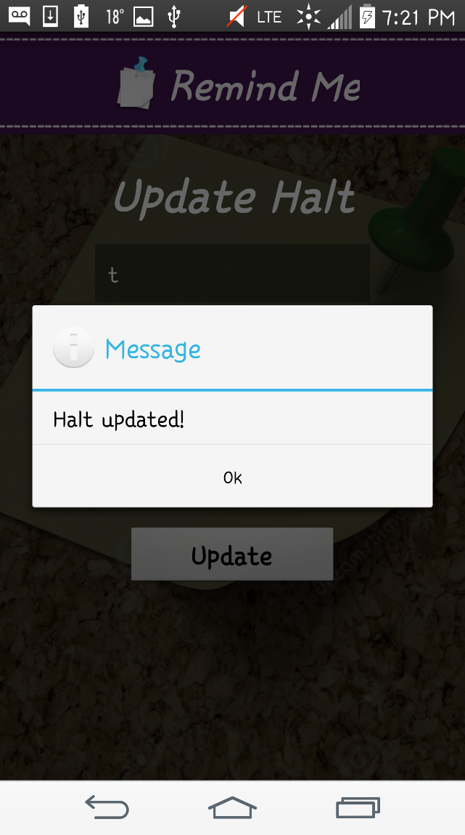 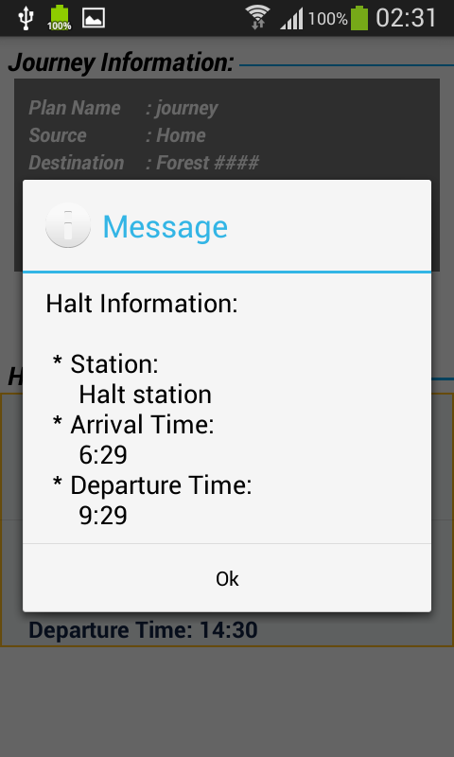

When the halt is updated a notification message on the window as show above.

It contains the arrival and departure time and station name etc.

**Step 12:**

If the user want to see any of the journey/ halt details it can be seen in the following windows by selecting the show button that is popped up when user select the respective journey.



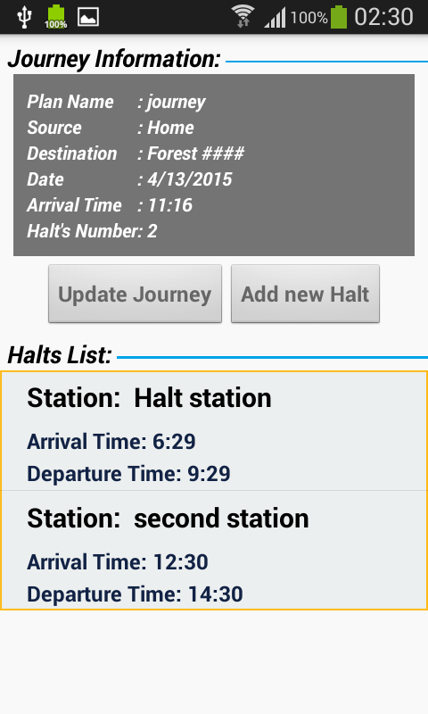

**Step 13:**

Similarly when the user wants to delete any of the journey / halt it can be done from the above shown popped up buttons. If the user deletes the journey / halt records and remainders the following confirmation dialogue boxes appears.

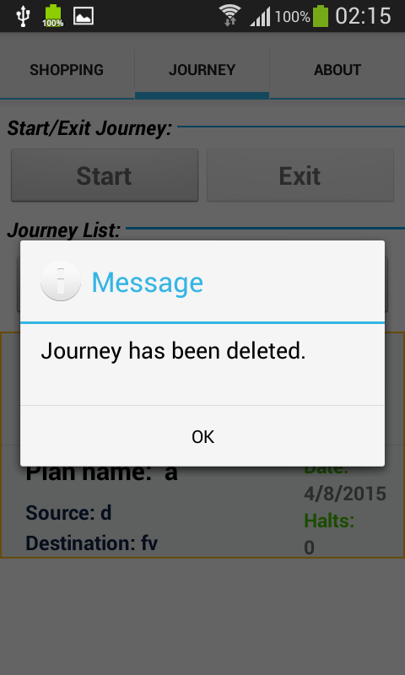 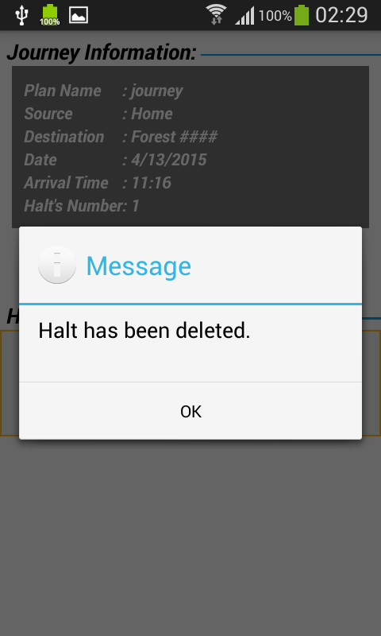

**Step 14:**

Once the user is ready and everything is done by providing the details the reminder is set and ready and the following window is displayed.

The notification of the alert is shown in the adjacent window as shown.

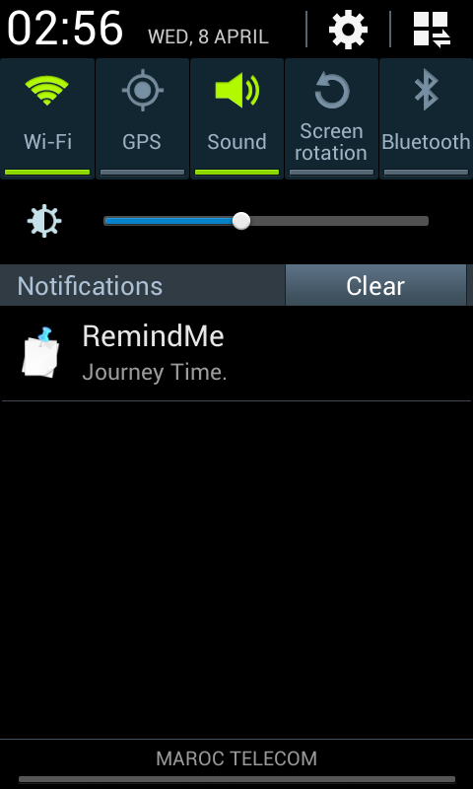

**Step 15:**

If the user wants to terminate or start and exit for journey tab, it can be done as follows.

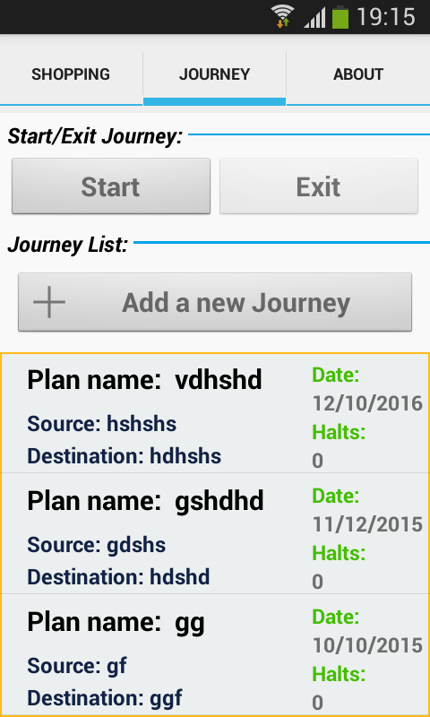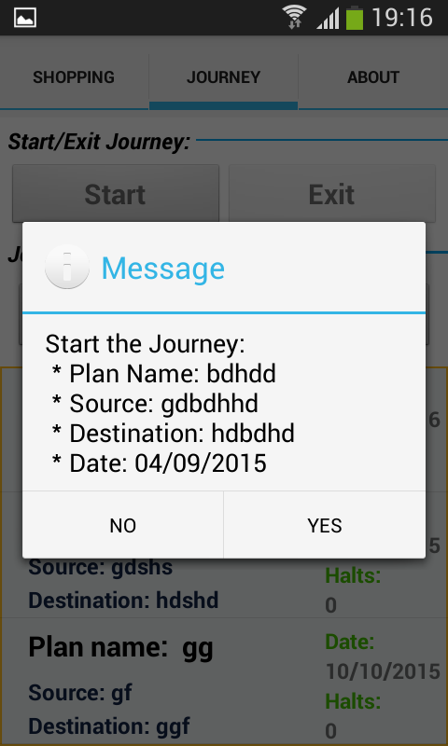

**Step 16**:

If the user wants to terminate or stop and exit for journey tab, it can be done as follows.

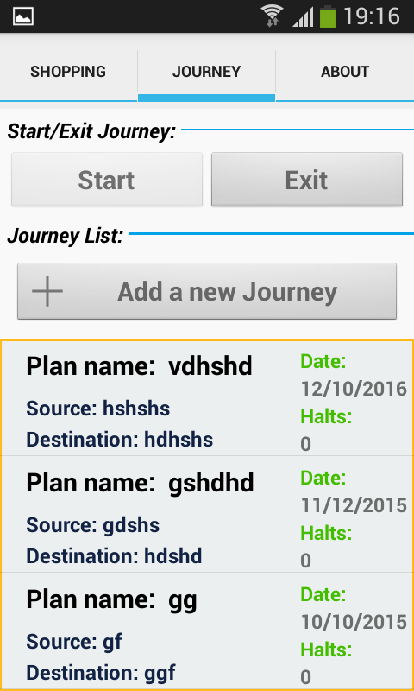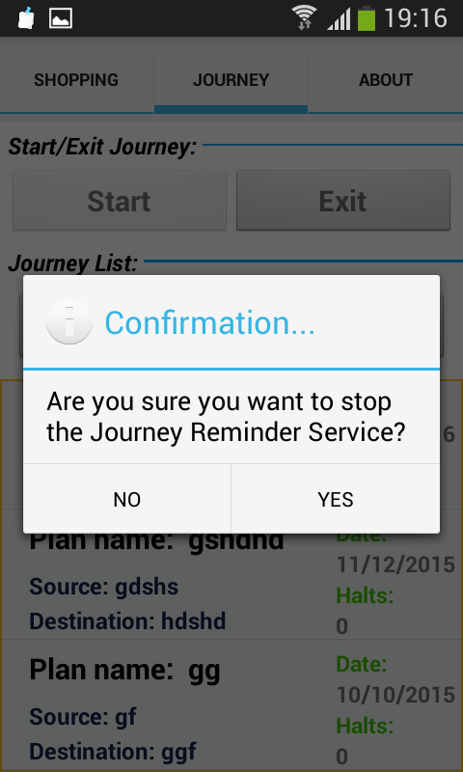

**Testing:**

Testing is done using Advanced Rest Client Services.

We are this testing as we have get, post methods and we get the reply instantly in json format.

**Journey services:**

1. Adding a new journey

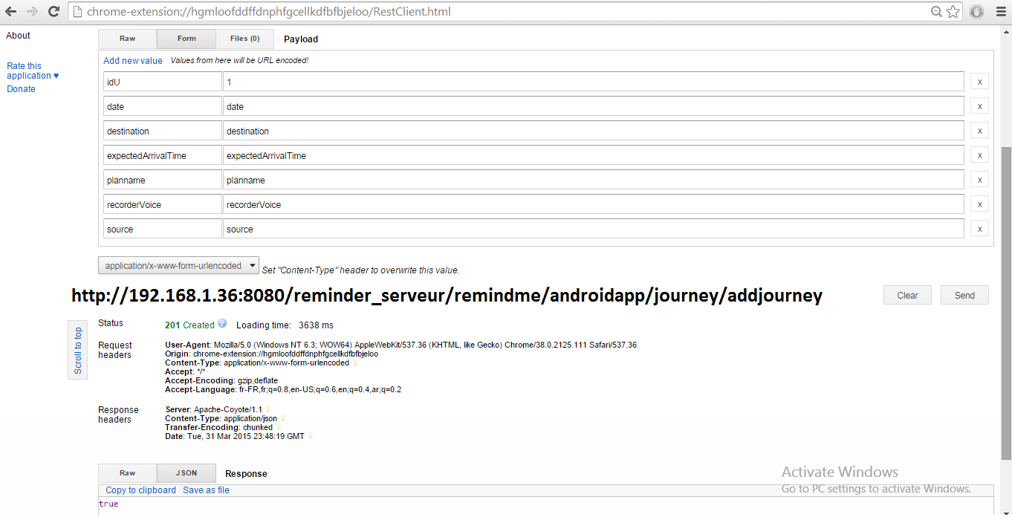

1. Deleting a journey: which is not successful as id mentioned doesn’t exist

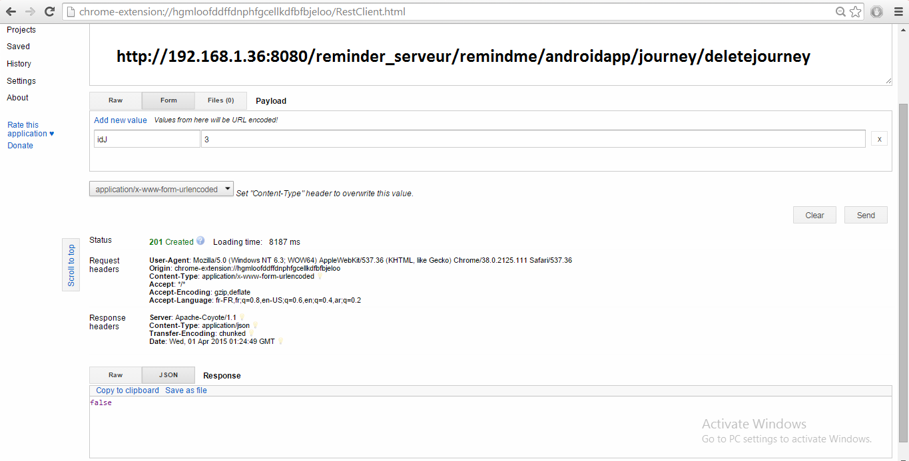

1. Deleting a journey: which is successful

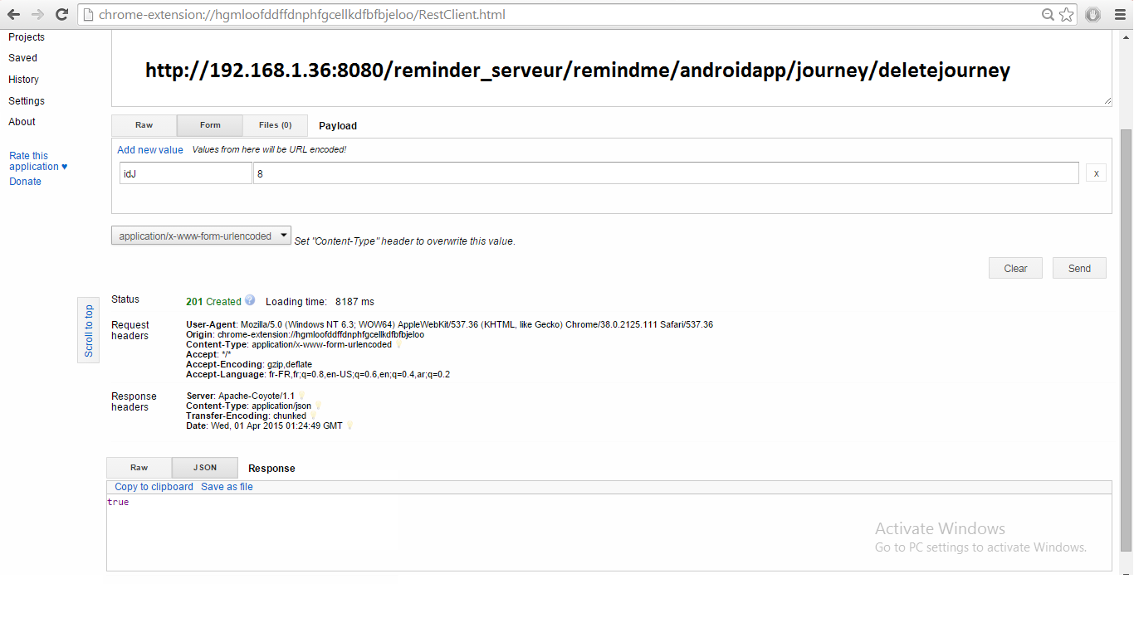

1. Getting a journey list with a particular id

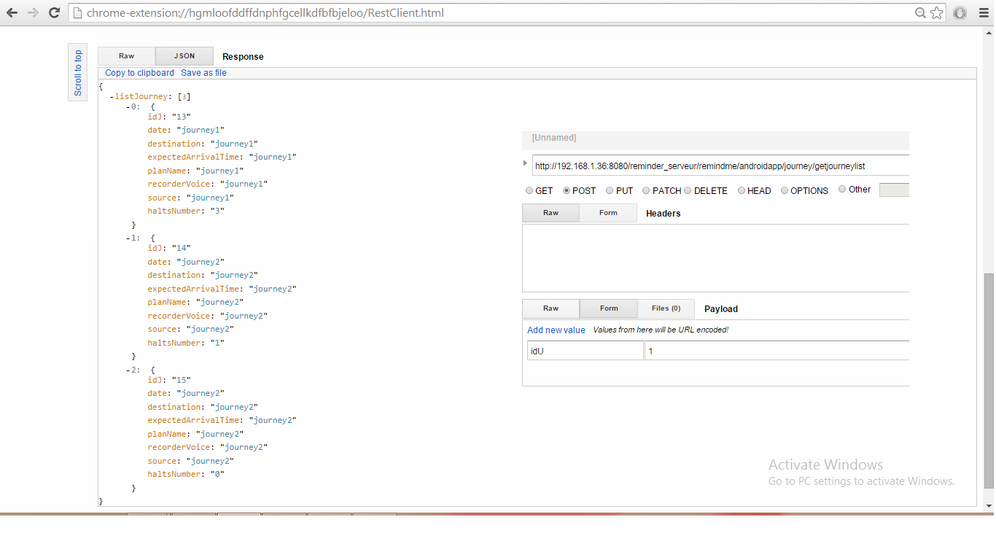

1. Getting a journey list of a particular id which doesn’t exist

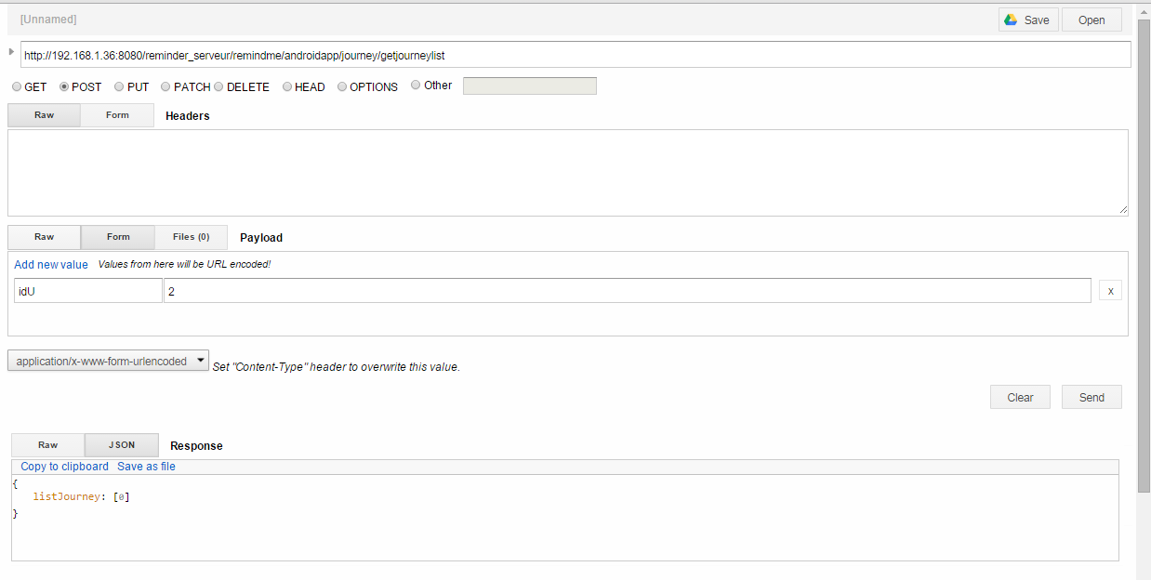

1. Updating a journey - which is not successful

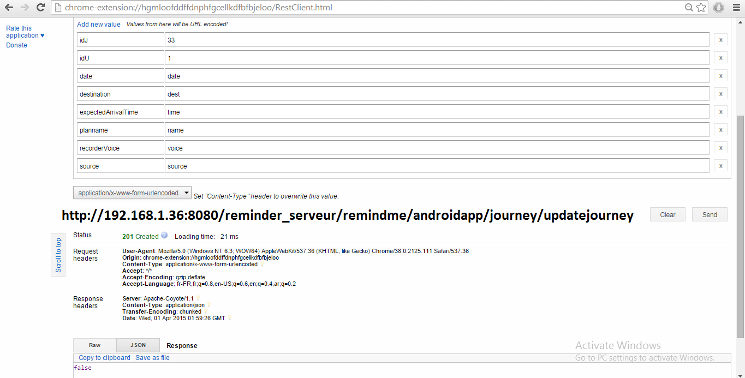

1. Updating a journey – which is successful

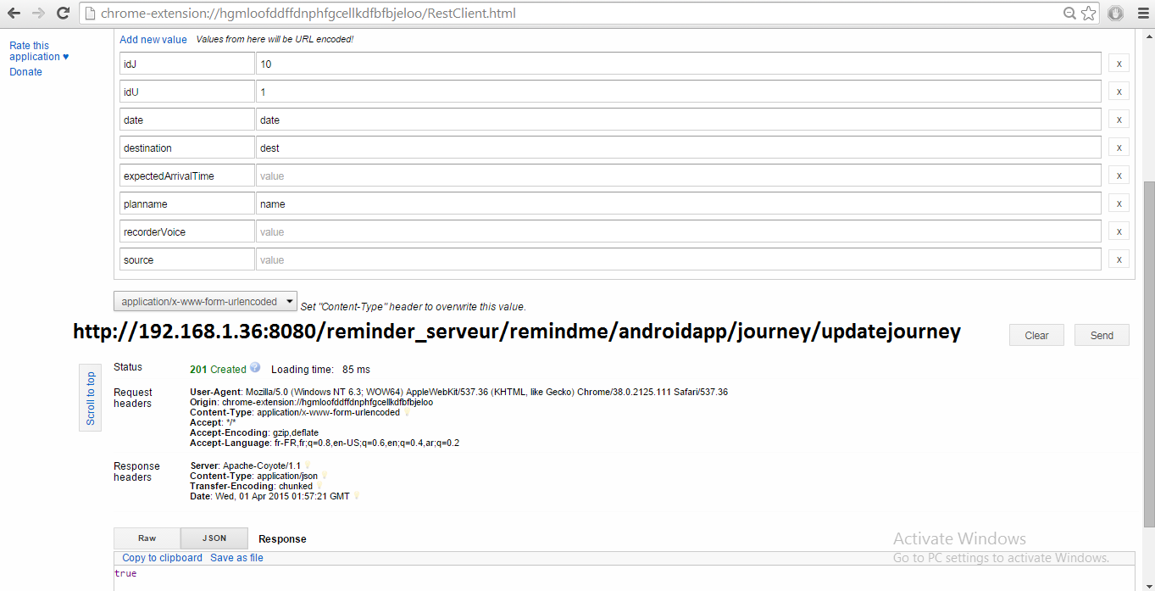

**Halt services:**

1. Adding a new halt

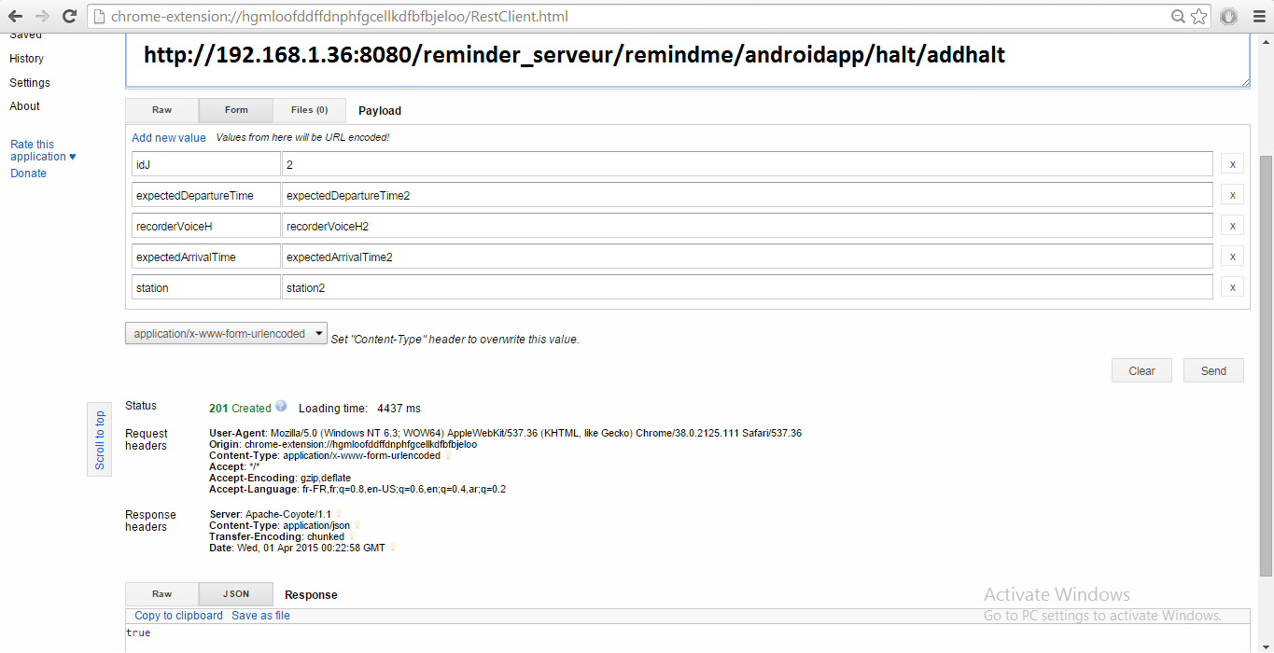

1. Deleting a halt – which is not successful

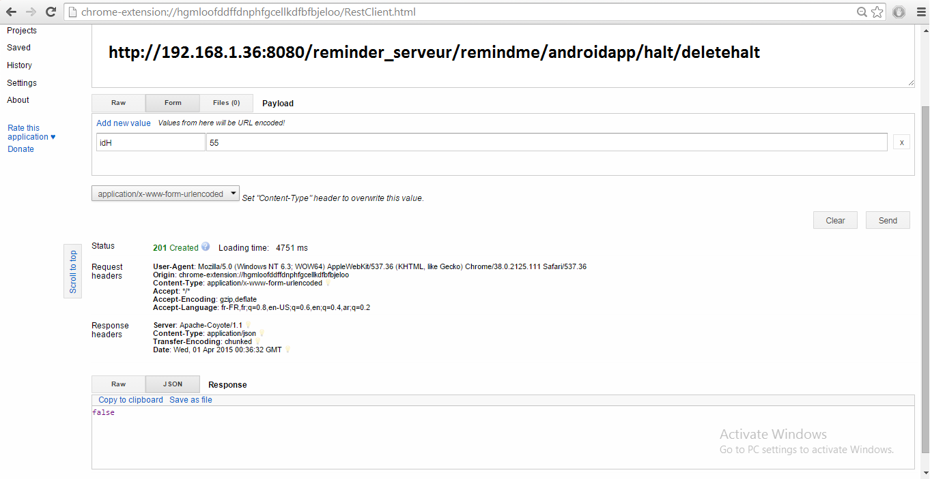

1. Deleting a halt – which is successful

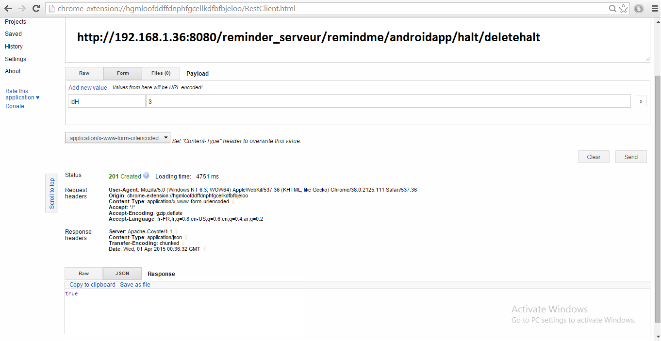

1. Displaying a halt list of a journey with only one halt.

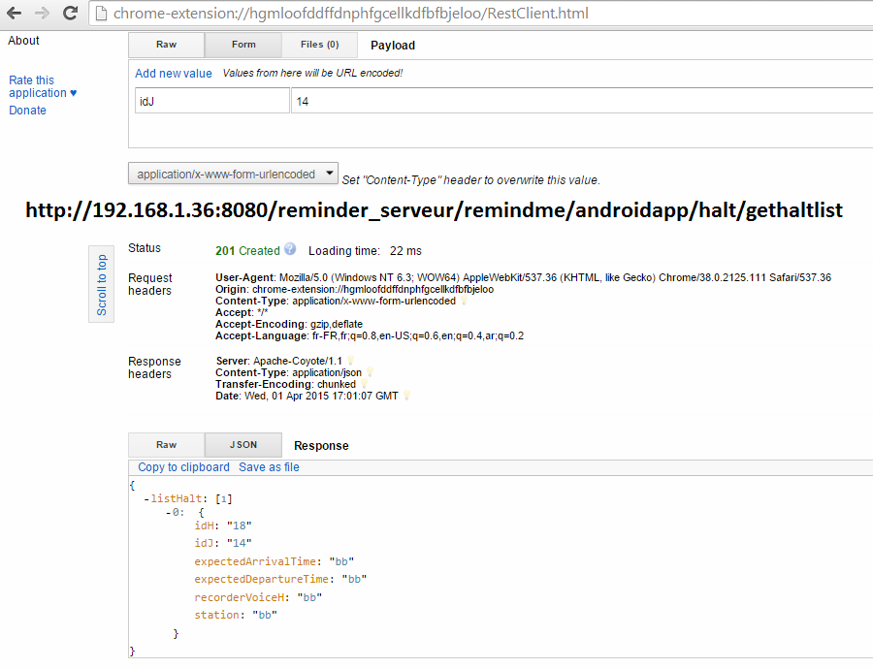

1. Getting a halt list of a journey with 3 halts

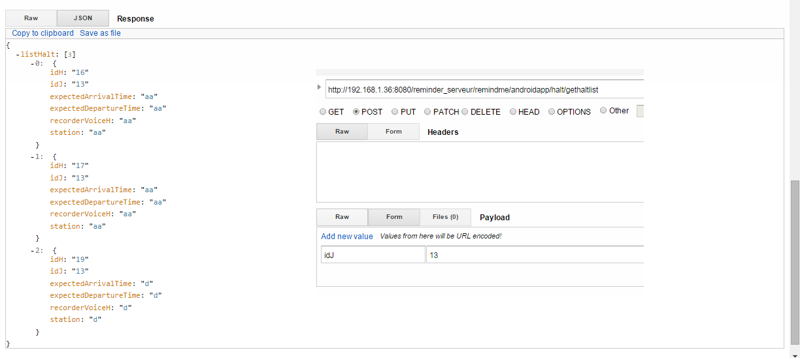

1. Displaying halt lists for an journey which doesn’t have any halt

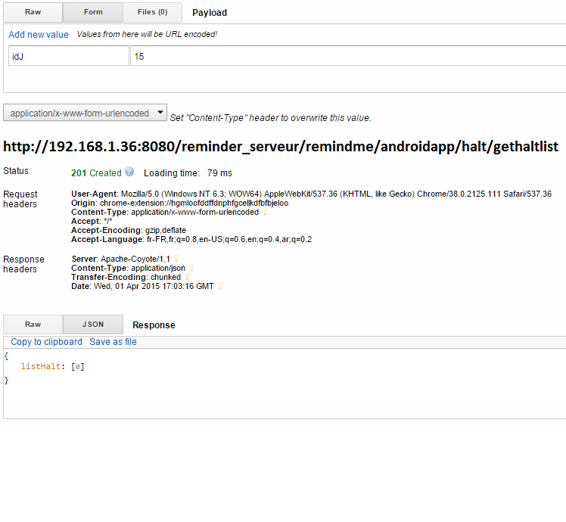

1. Updating a halt – which is not successful

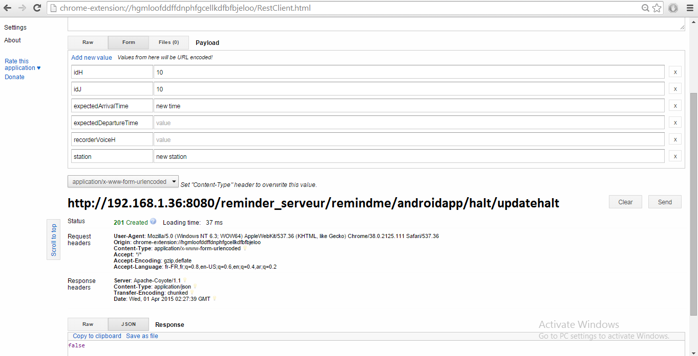

1. Updating a halt – which is not successful

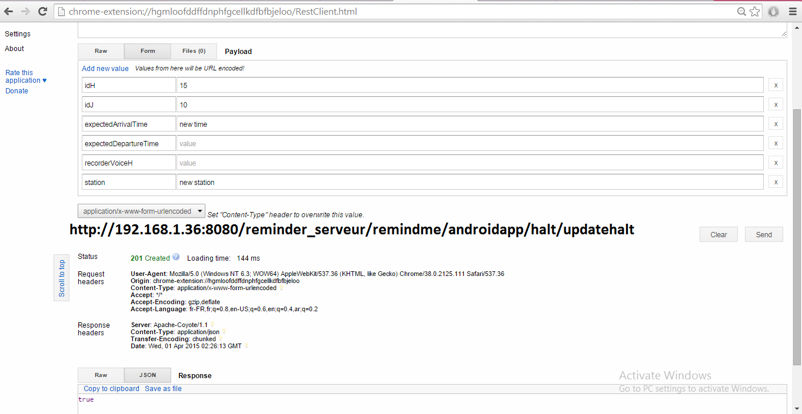

**PERFORMANCE TESTING USING DDMS TOOL:**

Dalvik Debug Monitor Server (DDMS) is a debugging tool in Android and it is having lot of features like thread and heap information on the device, log cat, process, location data spoofing, network traffic examining and more.

Here are certain features examined by DDMS Debugging tool.

1. **Examining the Thread information:**

For a selected process it examines the number of threads running for a selected process.

In this case for the process selected from the device tab “com.palreddy.remainder” it shows the information of all the threads for the process, their ids, and status of the threads**, Utime and Stime for the threads. This shows the performance indication for each thread and the whole process.**

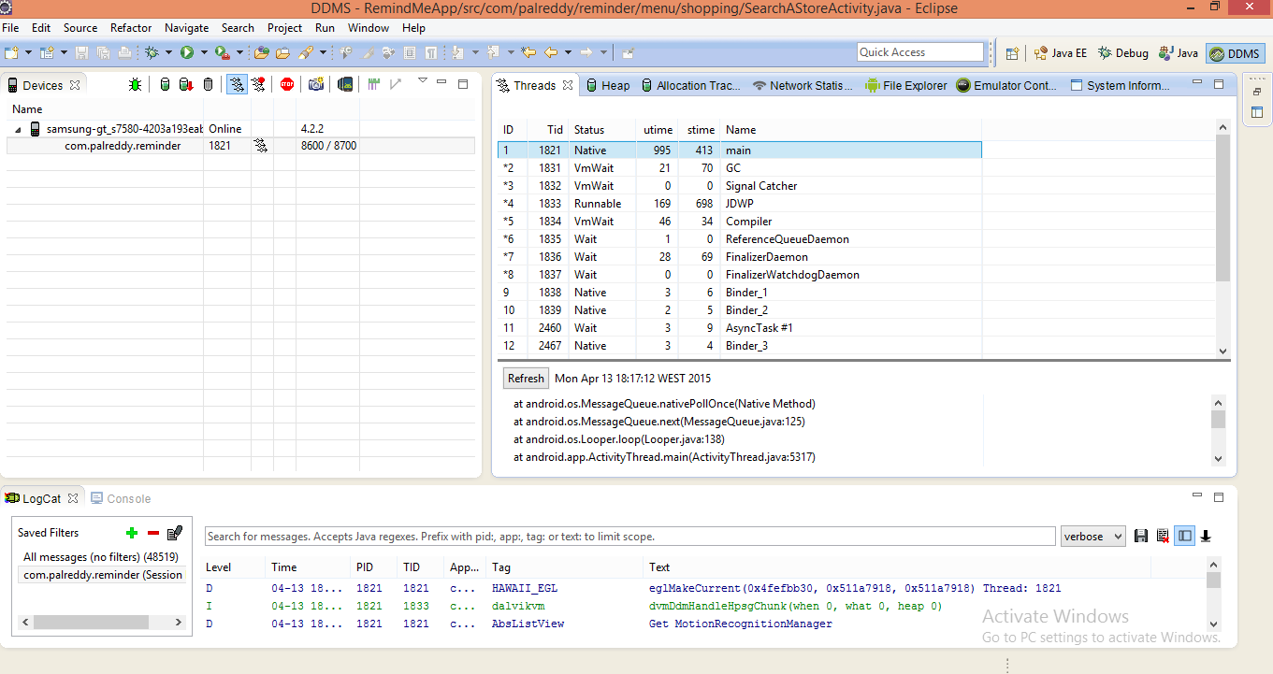

1. **Method Profiling**

In order to get more granular control over the collection of profiling data, we need to use startMethodTracing () and stopMethodTracing () methods.

On device tab by selecting startmethodtracing () and stopmethodtracing () we get the profiling information of the method.

Method profiling is used for tracking certain metrics for the method which are number of calls for the method, execution time of method.

**In this case it shows all methods for the journey tab and their CPU time for execution**.

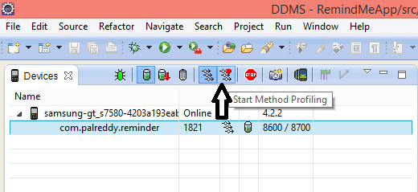

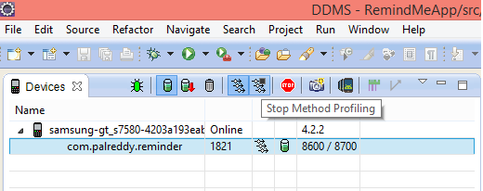

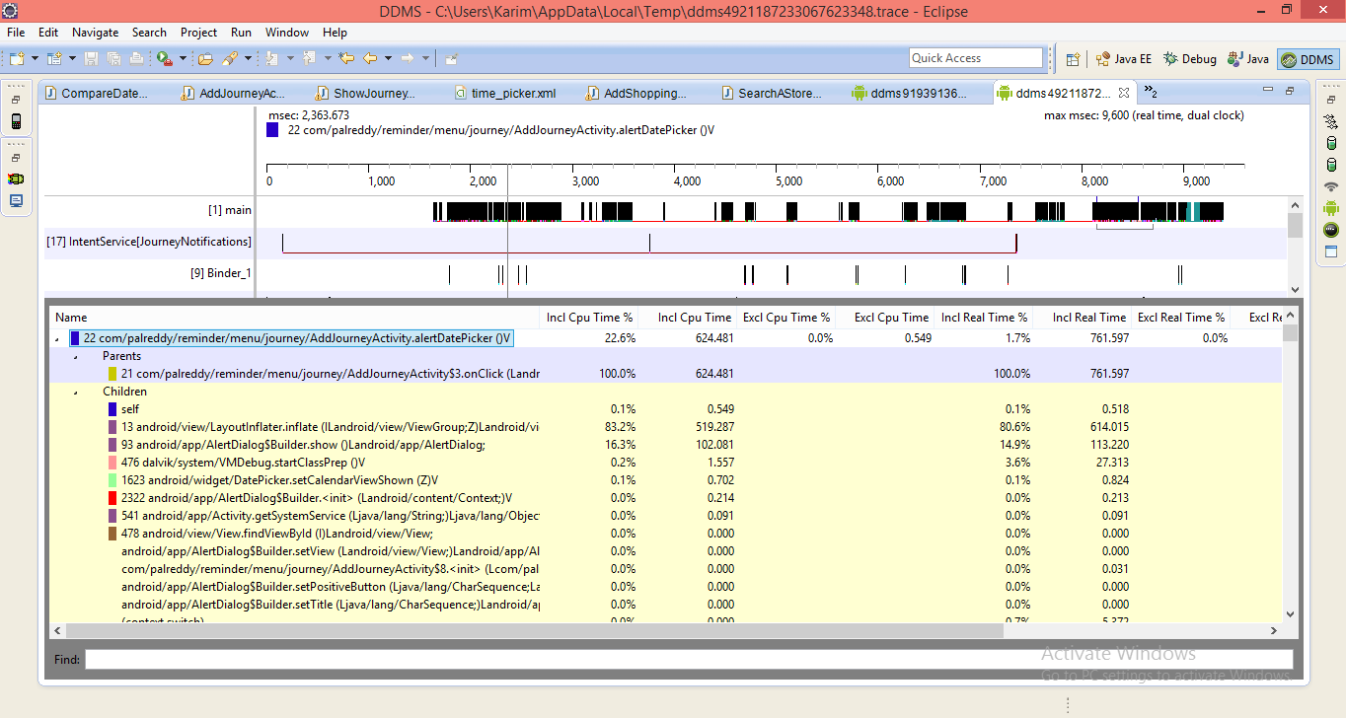

1. **Tracking memory allocations of objects**

**This information is useful to trace the objects of which class and thread are being allocated in the memory which is useful for accessing the memory usage which can affect the application performance**.

In this case for shopping tab the tracking of objects is performed and the allocations are examined between start and stop of the tracking button. On specific row selection it gives more detailed information about method and line number of the code allocated the object.

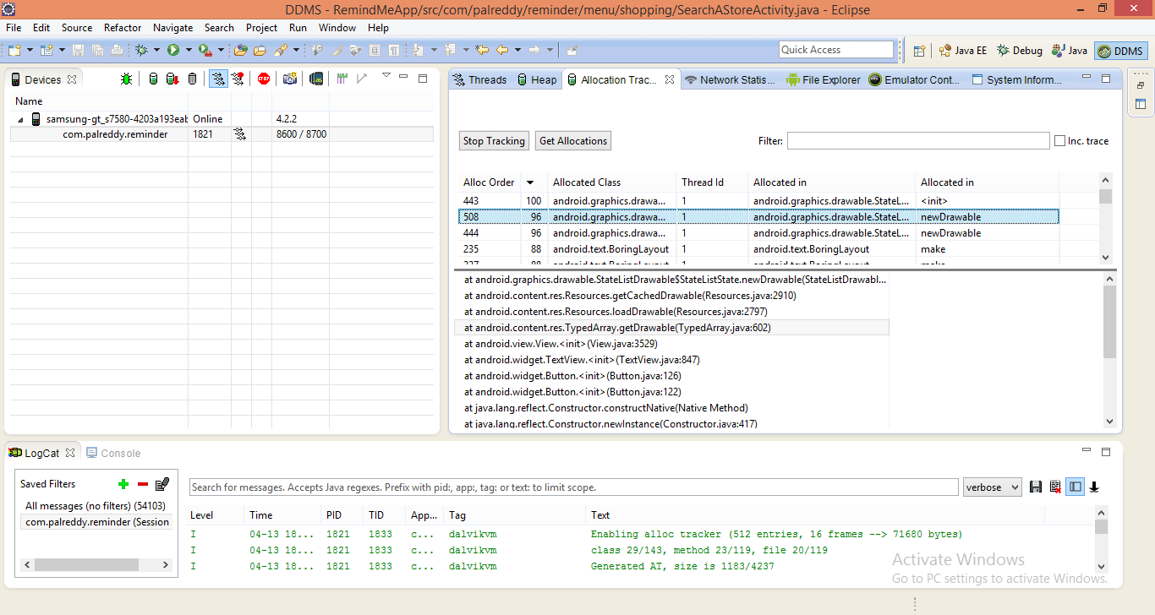

1. **Using LogCat**

LogCat is used to output the messages the same functionality done by the Log class. It also gives other message information like stack traces when exceptions are thrown. It is used to filter the messages output.

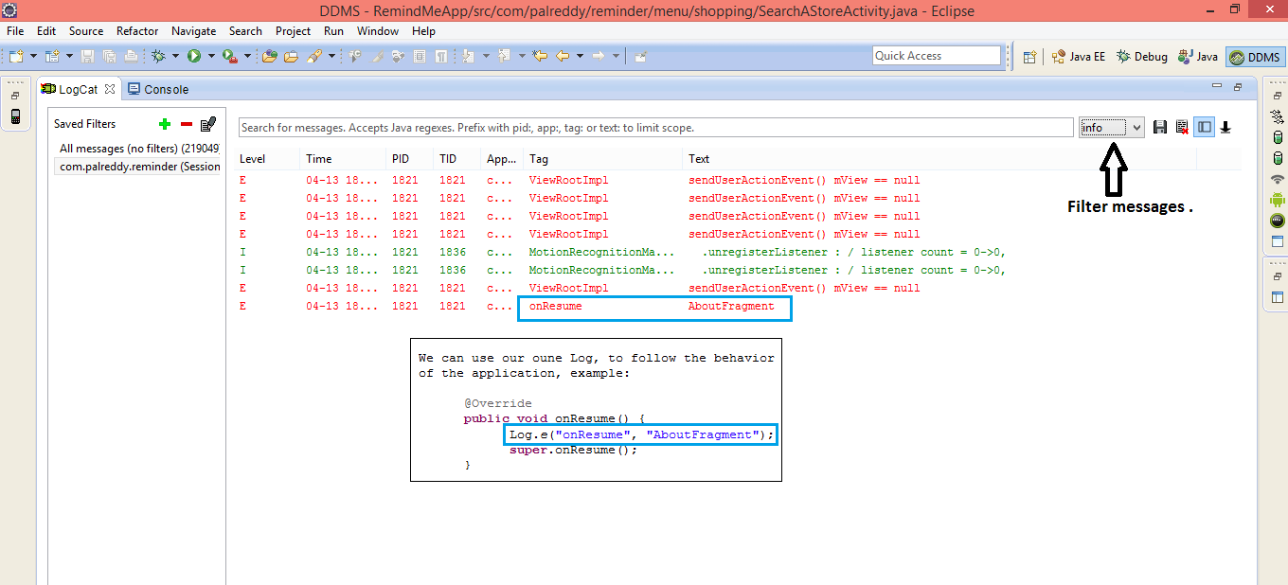

1. **Using the Network Traffic Tool**

**This feature in DDMS includes a detailed network usage tab that makes it possible to track the application when it is making Network requests.** This tool is used to monitor how and when the app transfers the data. It is also possible to distinguish different traffic types and by monitoring the frequency of the data transferred, we can identify the areas of app that can be made more battery efficient.

**In this case for the journey tab list, shopping tab list and halt list network performance is calculated.**

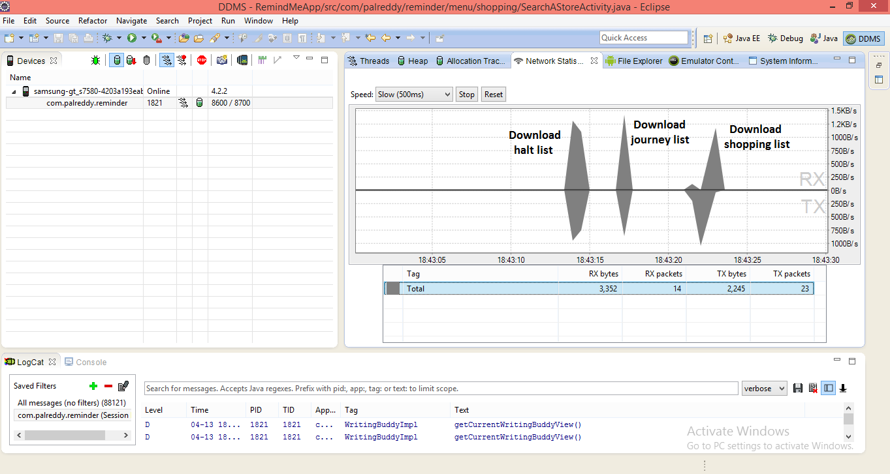

1. **Viewing Heap Usage for the process**

In order to see how much heap memory a process is using we need to do heap processing test. **This information is necessary to track the memory usage during the execution of application.**

In this case Heap usage is calculated for two processes and information obtained is about the objects and memory allocated. For a particular object type list on clicking it gives the bar graph information of number of objects allocated for that memory size. **This gives the performance of the app in case of memory management.**

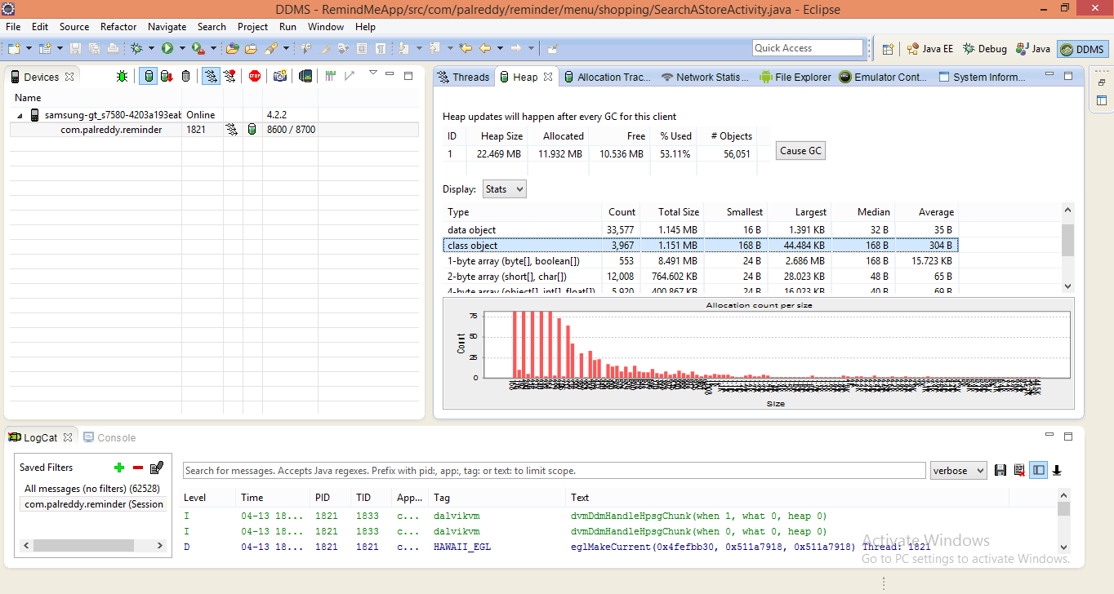

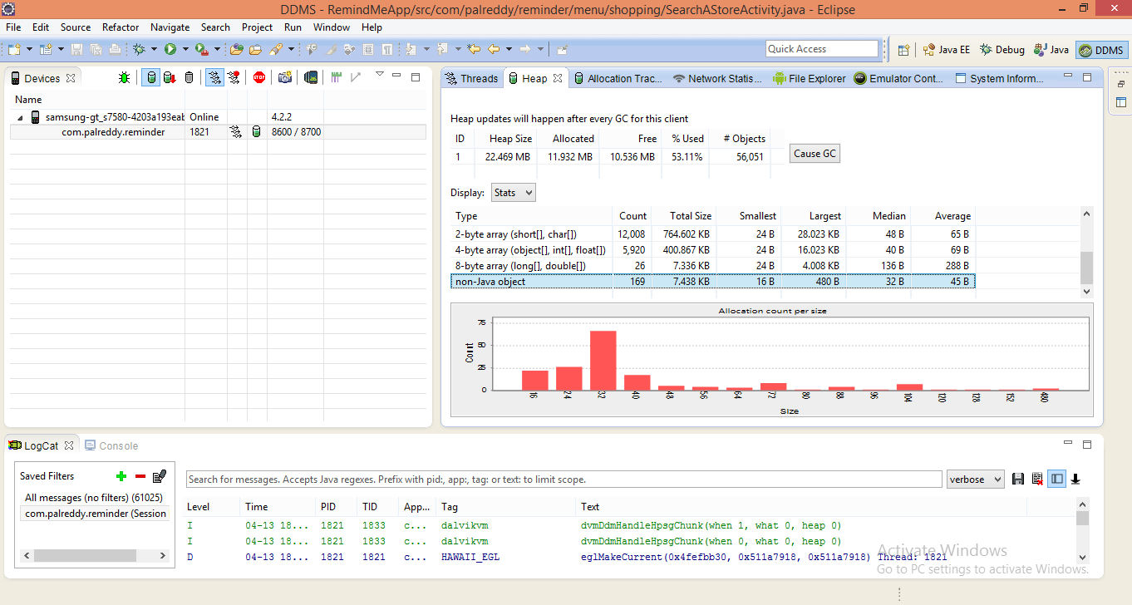

**Page Speed Insights:**

It is a tool designed to optimize the performance of the website, it shows about the issues in the page and how to fix it.

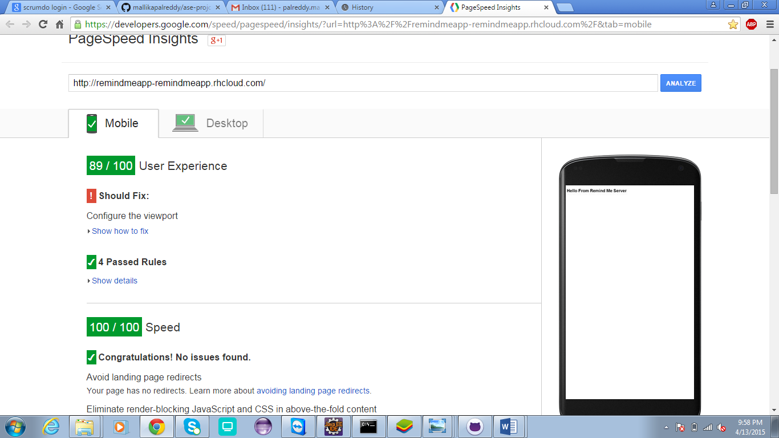

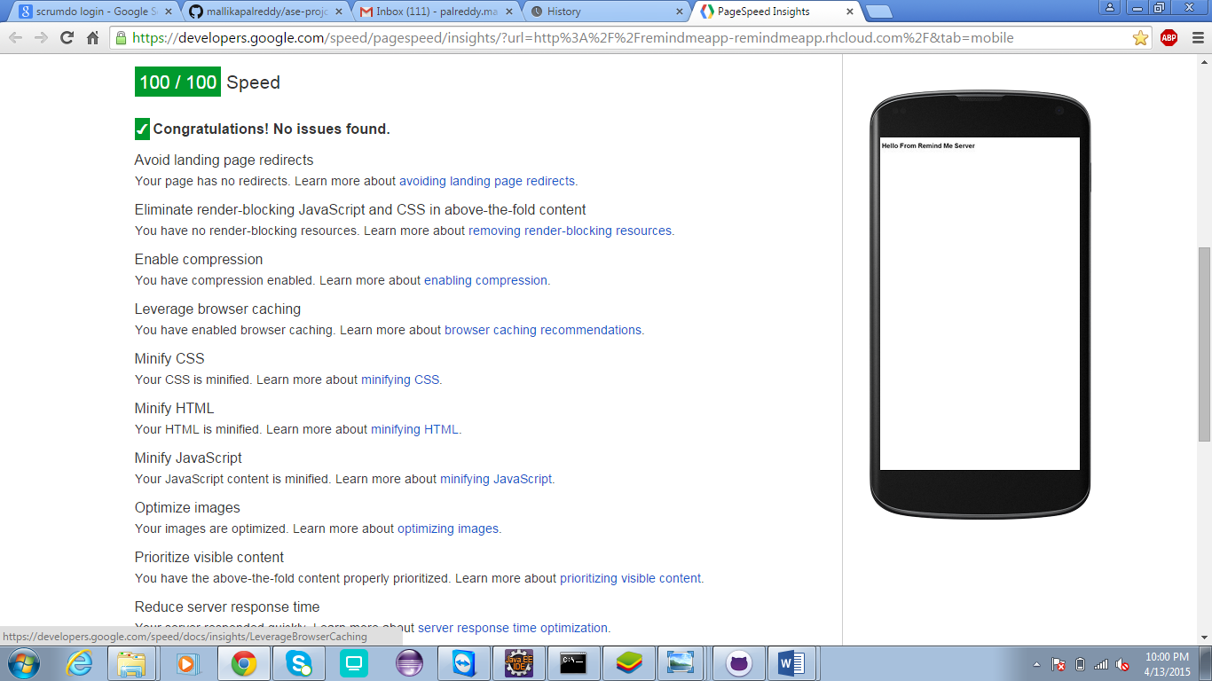

**Increment 4**

**Service description:**

The additional features we added to the application for increment 4.

1. ***Password encryption:***  we are using the encryption technique to encrypt password when the user sign up and I sock it (the password) crypted and send it to the database. So using this even the database admin cannot know the exact password except the user.

For this we used a hash function, SHA-2, like any hash function, it gives you as a output a fixed length string, whatever was the length of your password, the hash is 256 bits length. And it is a strong hash not like SHA-1 or MD5 or any other one.

1. In the shopping tab, we added feature to set the time also used Google maps API , to provide exact location of the store
2. In the journey tab, we added more features like the user can provide exact location of the source, destination and halts.
3. We added description about out app briefly in the about tab, which aids the new users to know about our application.

For selecting the address using the maps, after entering the address in the search box, the user has to click on the marker to add the location.

**SCRUMDO Screen Shits:**

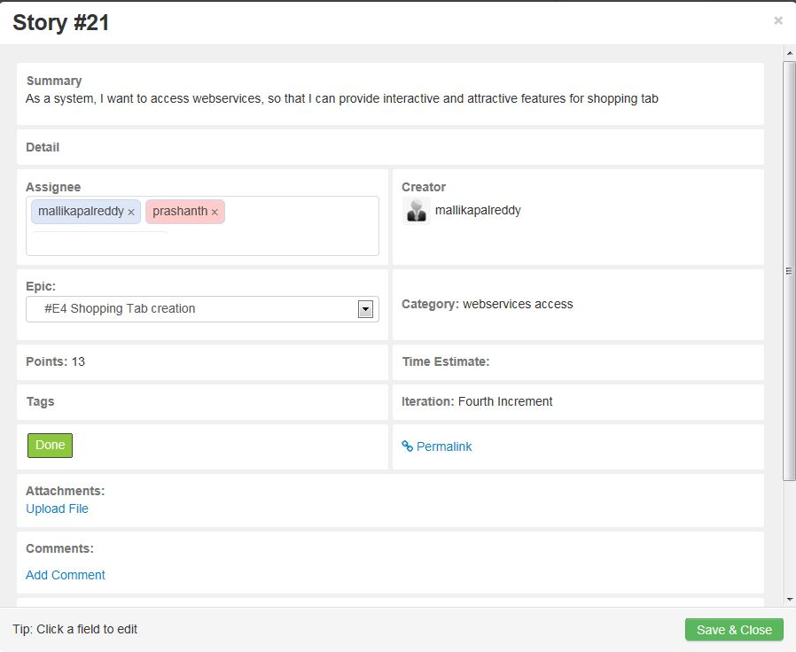

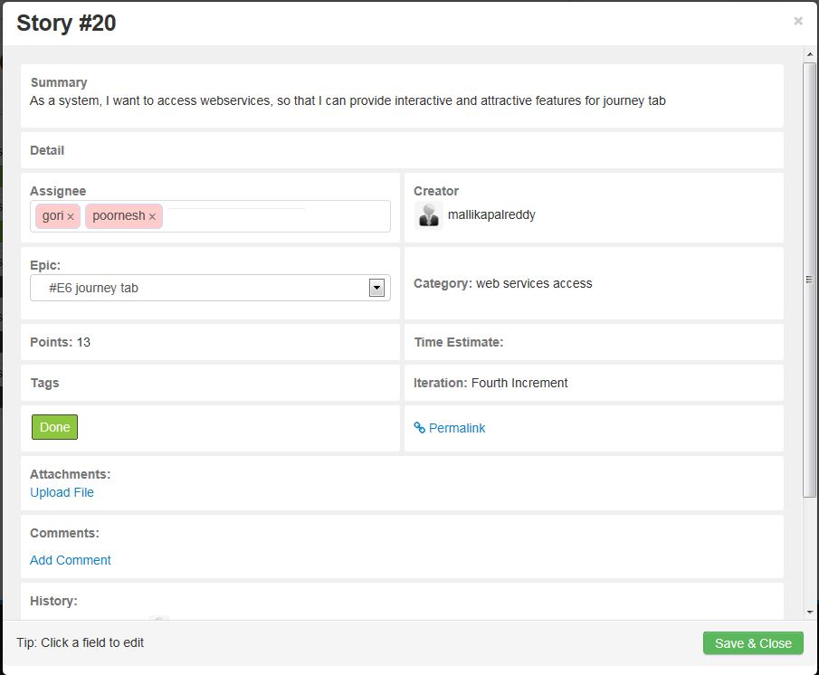

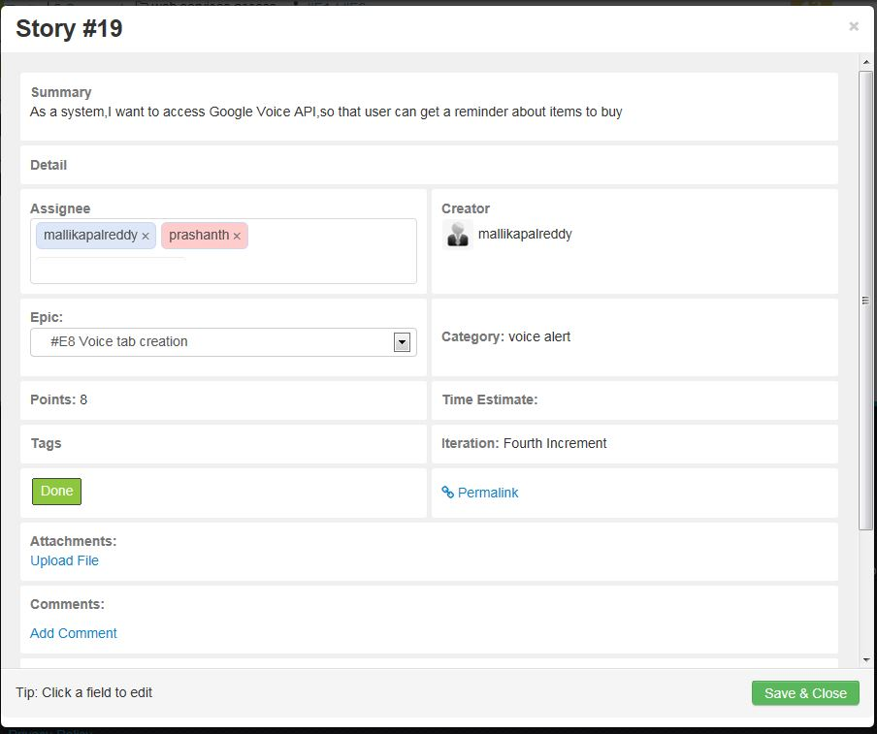

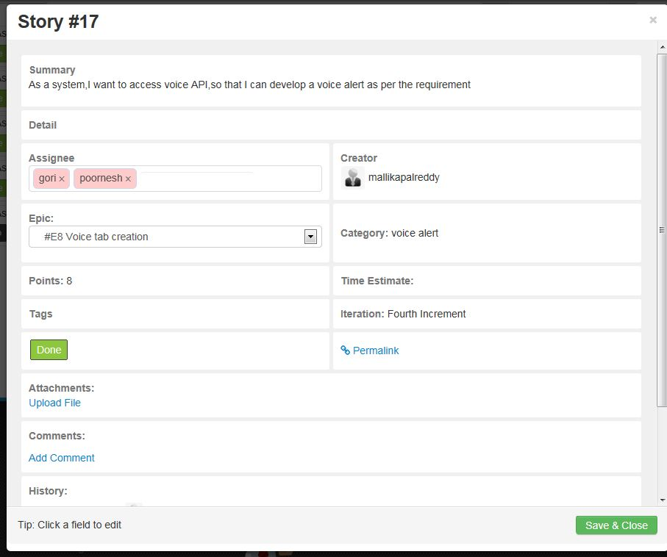

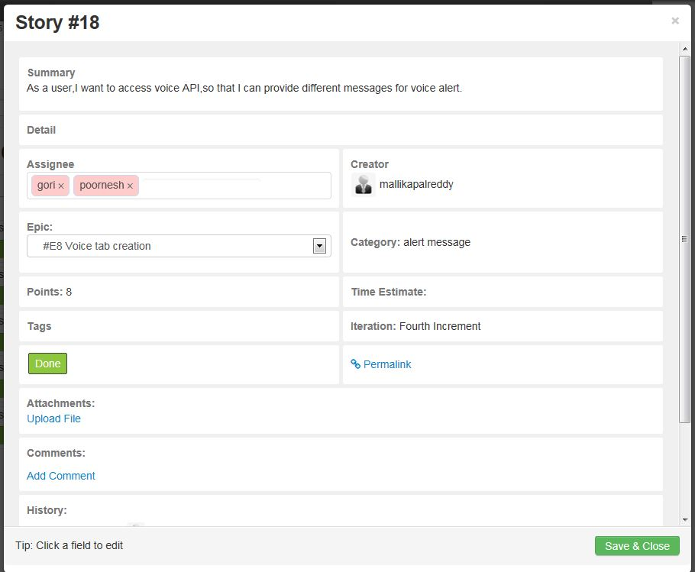

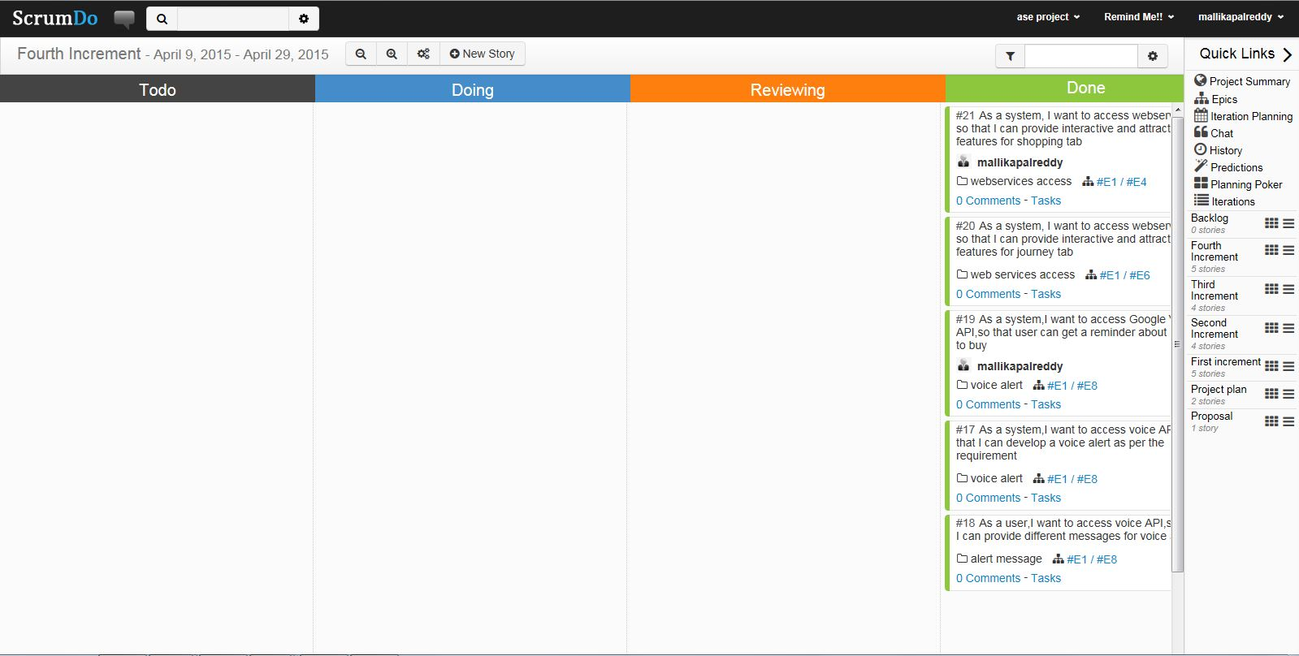

**Class Diagrams:**

**Class Diagrams:**

**Shopping tab:**



**Journey tab**



**Shopping tab**



**Journey tab:**



**Design of mobile client interface:**

Here we have added the google maps search engine icon as shown below

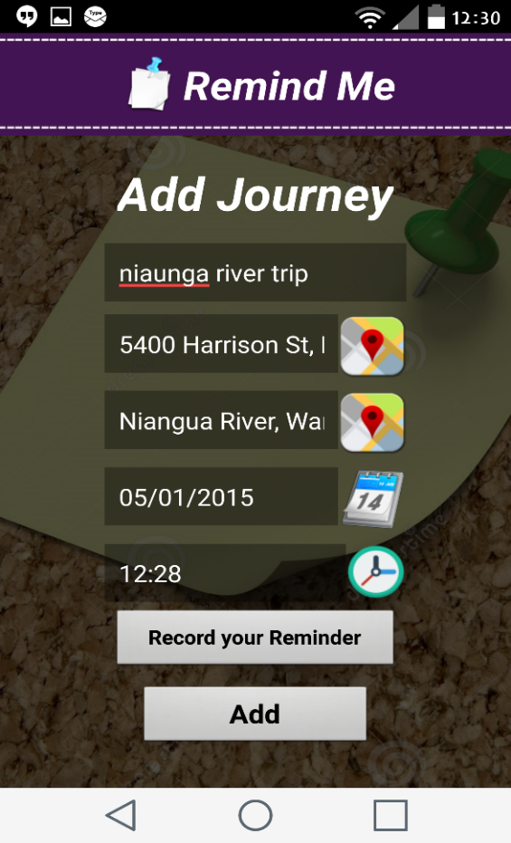 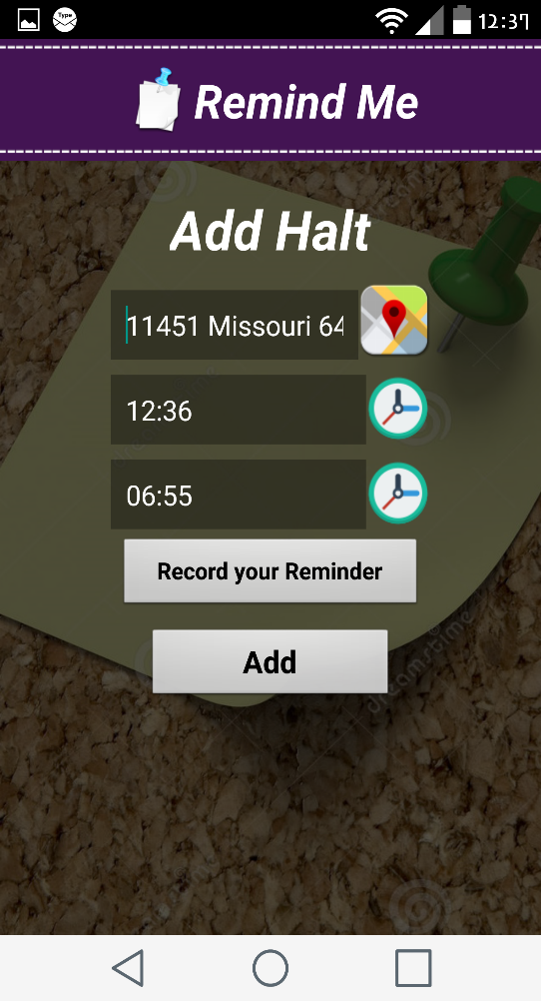

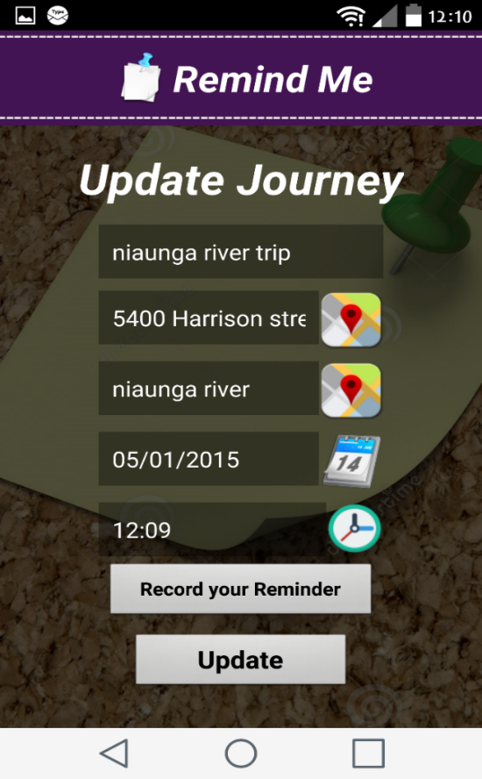 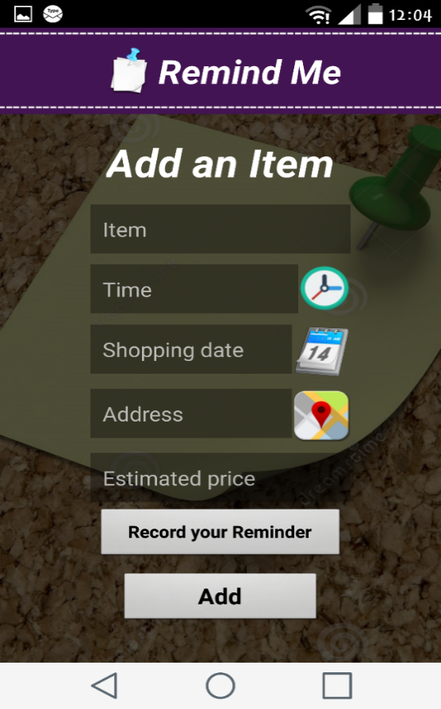

1. **LogCat usage:**

It outputs the messages in which we can find all the log information the same thing done by log class. When any exceptions are thrown it gives the stack trace details of that. Message outputs can also be filtered.

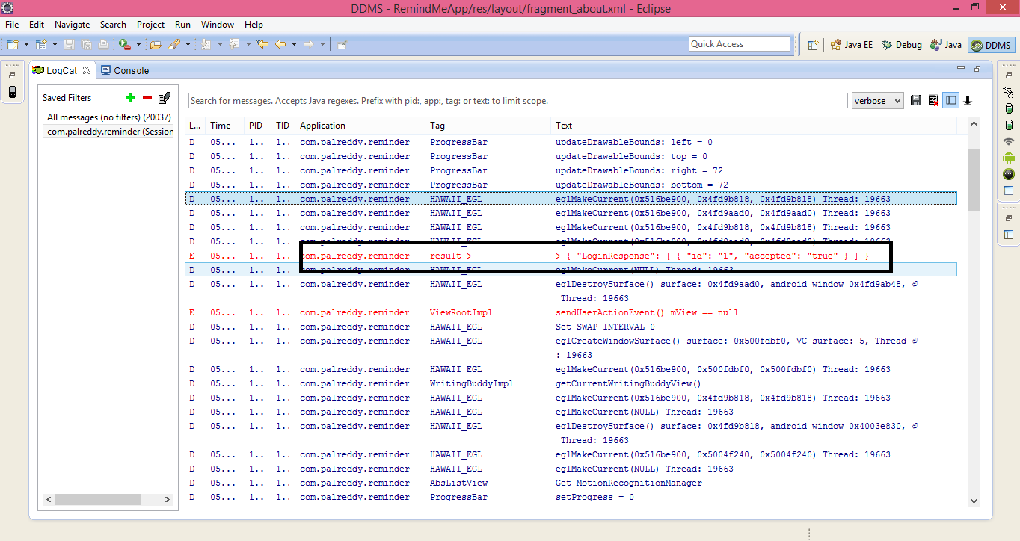

1. **Network Traffic Tool Usage:**

When a network request is made the network usage tab in DDMS will track the application. This information gives about the when app transfers the data, by monitoring the frequency of data transferred, the information is valuable to modify the app in giving more battery life.

Here we considered journey lab list, Shopping tab list and halt list to calculate their network performance.

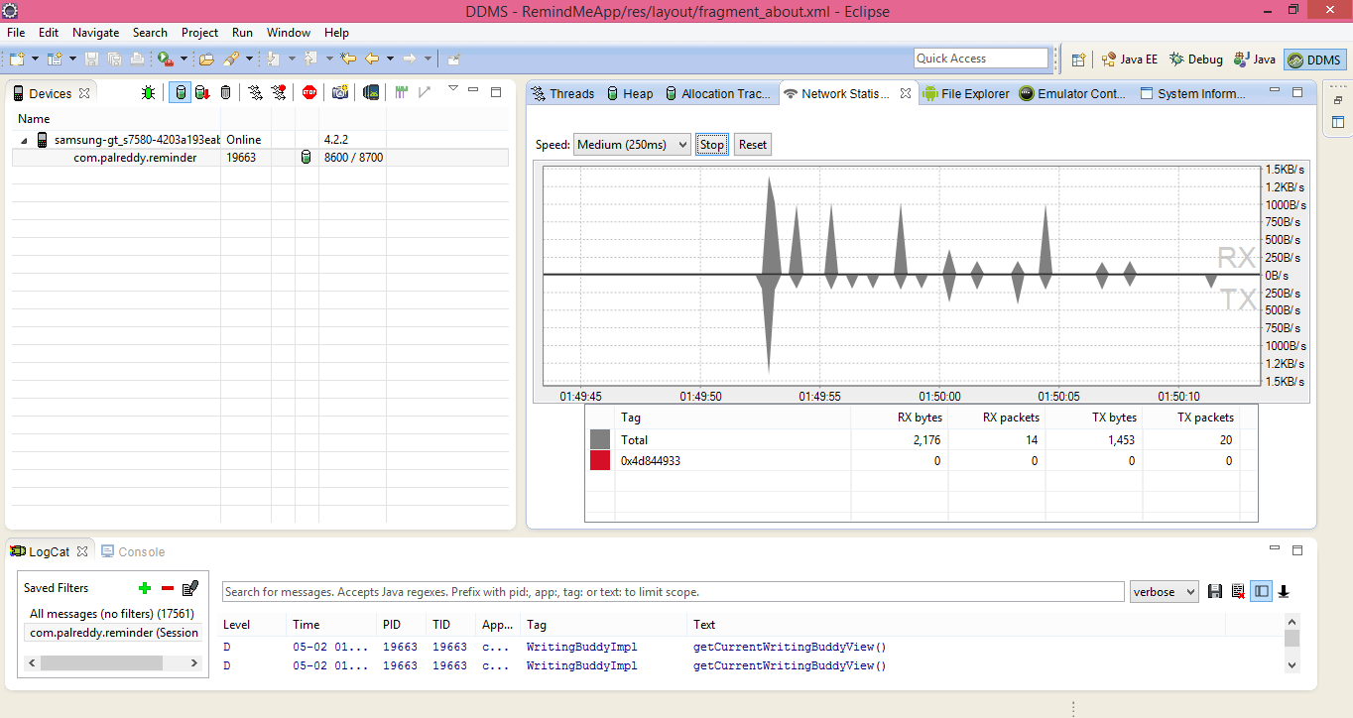

1. **Checking the process Heap Usage**

Heap processing test is useful to view the heap memory a process is using. This information is needed to track the memory usage during the execution of the application.

Here the test run on two processes, and obtained information about objects and memory allocated to those processes. Number of objects allocated for that memory size details also be obtained by checking the object type list. The information outcome is in terms of a bar graph. This is the performance details of app in memory management.

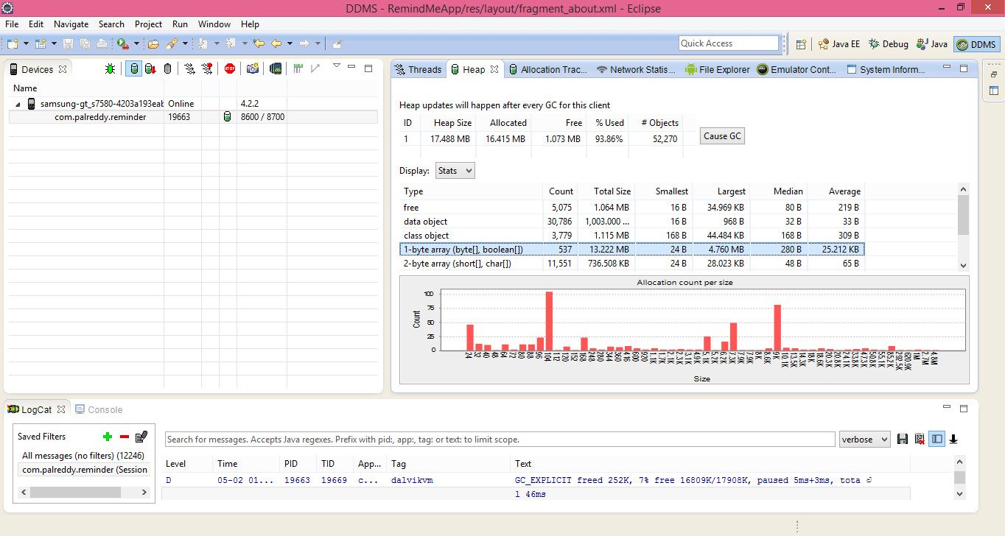

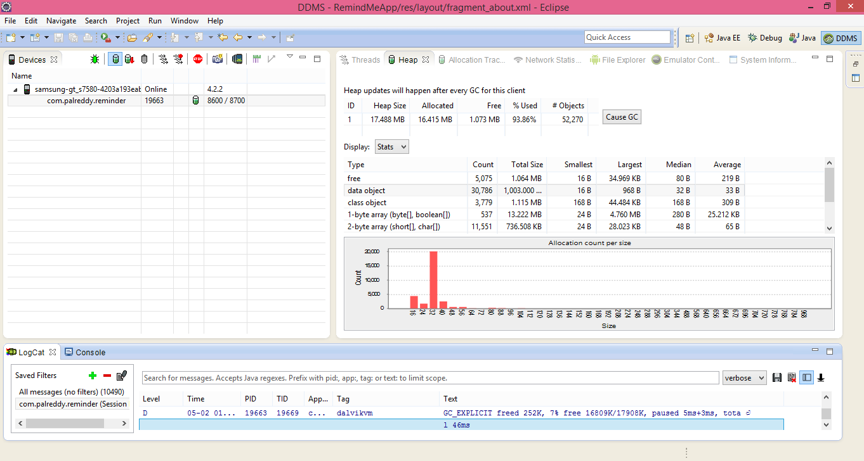

**Page Speed Insights:**

This tool is useful to optimize the performance of the website, it gives details about the page issues in the website and how can fix those issues.





**GitHub link**:

Final documentation:

Video link:

<https://www.youtube.com/watch?v=mGJblZs6H-U&edit=vd>

**ACKNOWLEDGEMENT**

This work was done in partial fulfillment of the requirements of

CS551: Advanced Software Engineering,

CSEE Department,

University of Missouri – Kansas City (Fall 2014).

Instructor: Dr. Yugyung Lee,

TA: Mayanka Chandrashekar

Malathy Krishnan

Bharat vishwanadham